**Contents**

1-Project 3

1.1. Project Topic 3

1.2.Goal Of The Project 3

1.3.The Success Criteria Of The Project 4

2-Dataset 4

2.1. Data Discovery And Preparation 5

2.2. Data Visiualization 6

3- Machine Learning 10

3.1. Section 1 -Machine Learning Algorithm 11

1-Decision Tree Classifier 11

2-Random Forest 13

3-Support Vector Machines 14

4-Logistic Regression 16

5-Naïve Bayes 17

6-Adaptive Boosting 17

7-KNN Algorithm 18

Comparison of Results After Section1: 21

3.2.Section2- Machine Learning Algorithm 21

1-Decision Tree Classifier 21

2- Random Forest 23

3-Support Vector Machine 24

4-Logistic Regression 25

5-Naïve Bayes 26

6-Adaptive Boosting 27

7-KNN Algorithm 28

Comparison Results After Section2 29

1-Project

1.1. Project Topic

Heart Disease Data Mining- Multi-Source Data Fusion and Analysis for Clinical. In this project, data mining methods related to heart disease were utilized to analyze data obtained from various clinical sources. Throughout this process, a dataset comprising the combination of five separate datasets containing different variables such as patients' age, gender, blood pressure tests, and more was employed. Subsequently, these data were scrutinized in terms of relationships and attributes that could be employed to identify and diagnose risk factors for heart disease.

1.2.Goal Of The Project

This project aims to promote the use of data mining and machine learning techniques for the early diagnosis and effective treatment of heart diseases. Heart disease is recognized as one of the leading causes of death worldwide, and early diagnosis and effective treatment can prevent disease progression or manage risk factors, thereby improving quality of life. Therefore, this project focuses on analyzing data obtained from various clinical sources to identify risk factors crucial for the determination, diagnosis, and treatment of heart disease.

1.3.The Success Criteria Of The Project

The extent to which the developed models can be integrated into clinical practice and the methods for achieving this integration, as well as the potential contribution of these models to diagnostic and treatment outcomes, may be regarded as definitive indicators of success. The success of this integration would reflect the potential of advanced technologies to be effectively utilized in enhancing the quality of healthcare services and improving patients' health outcomes.

2-Dataset

The heart disease dataset has been constructed by combining five popular heart disease datasets that were previously available independently but not aggregated before. This amalgamation process aimed to create a comprehensive dataset encompassing a wide range of data obtained from various sources. Such integration facilitates a more extensive analysis. The five datasets used for its curation are:

* Cleveland
* Hungarian
* Switzerland
* Long Beach VA
* Statlog (Heart) Data Set.

This dataset consists of 1190 instances with 11 features. The attribute descriptions for the heart disease dataset and the description of nominal attributes are provided in Figures 2.1 and 2.2, respectively.

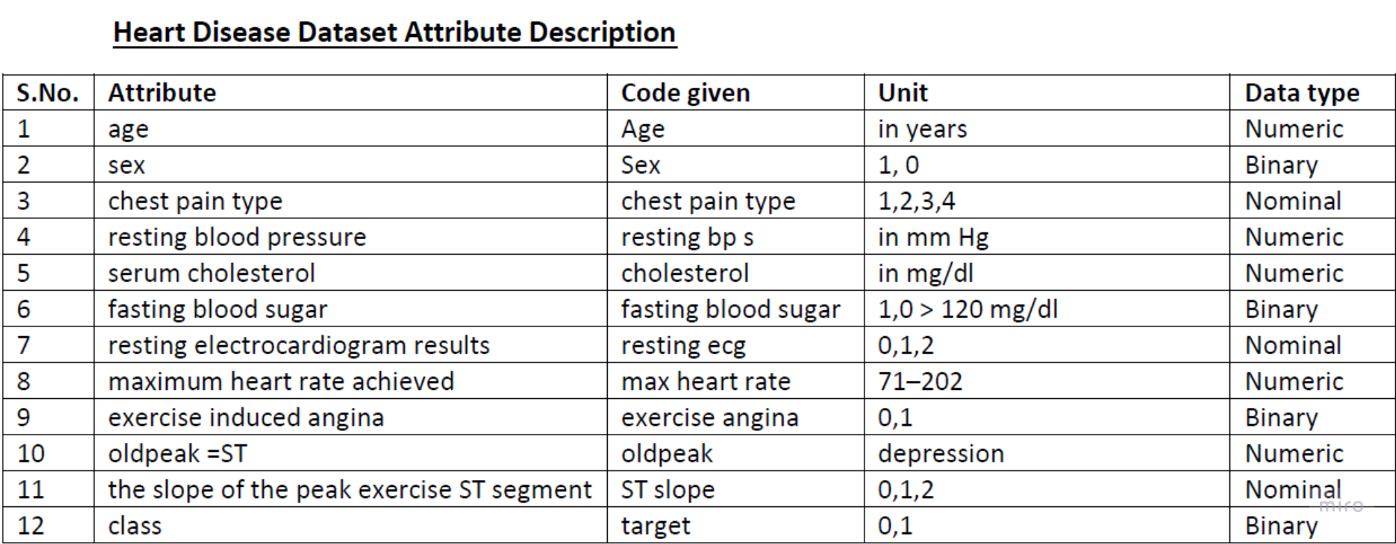

Figure 2. Heart Disease Dataset Attribute Description

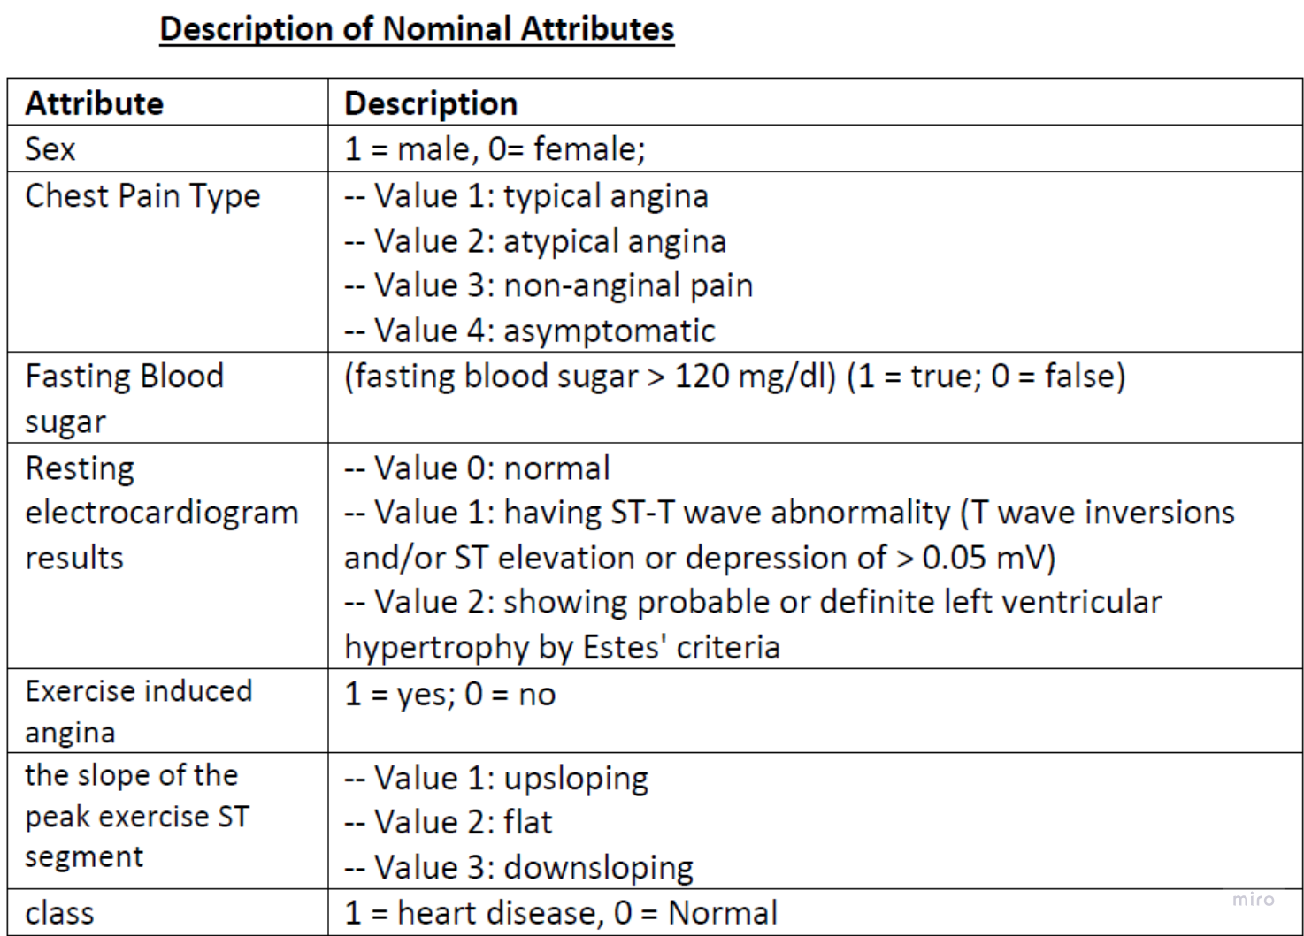

Figure 2. Description Of Nominal Attributes

2.1. Data Discovery And Preparation

Firstly, the numerical data in the dataset were categorized into specific groups and classified. This step involved grouping each feature in the dataset into certain intervals or values, thus making them more suitable for use in data analysis and modeling processes. The old and new tables are provided in Figures 2.1.1 and 2.1.2, respectively.

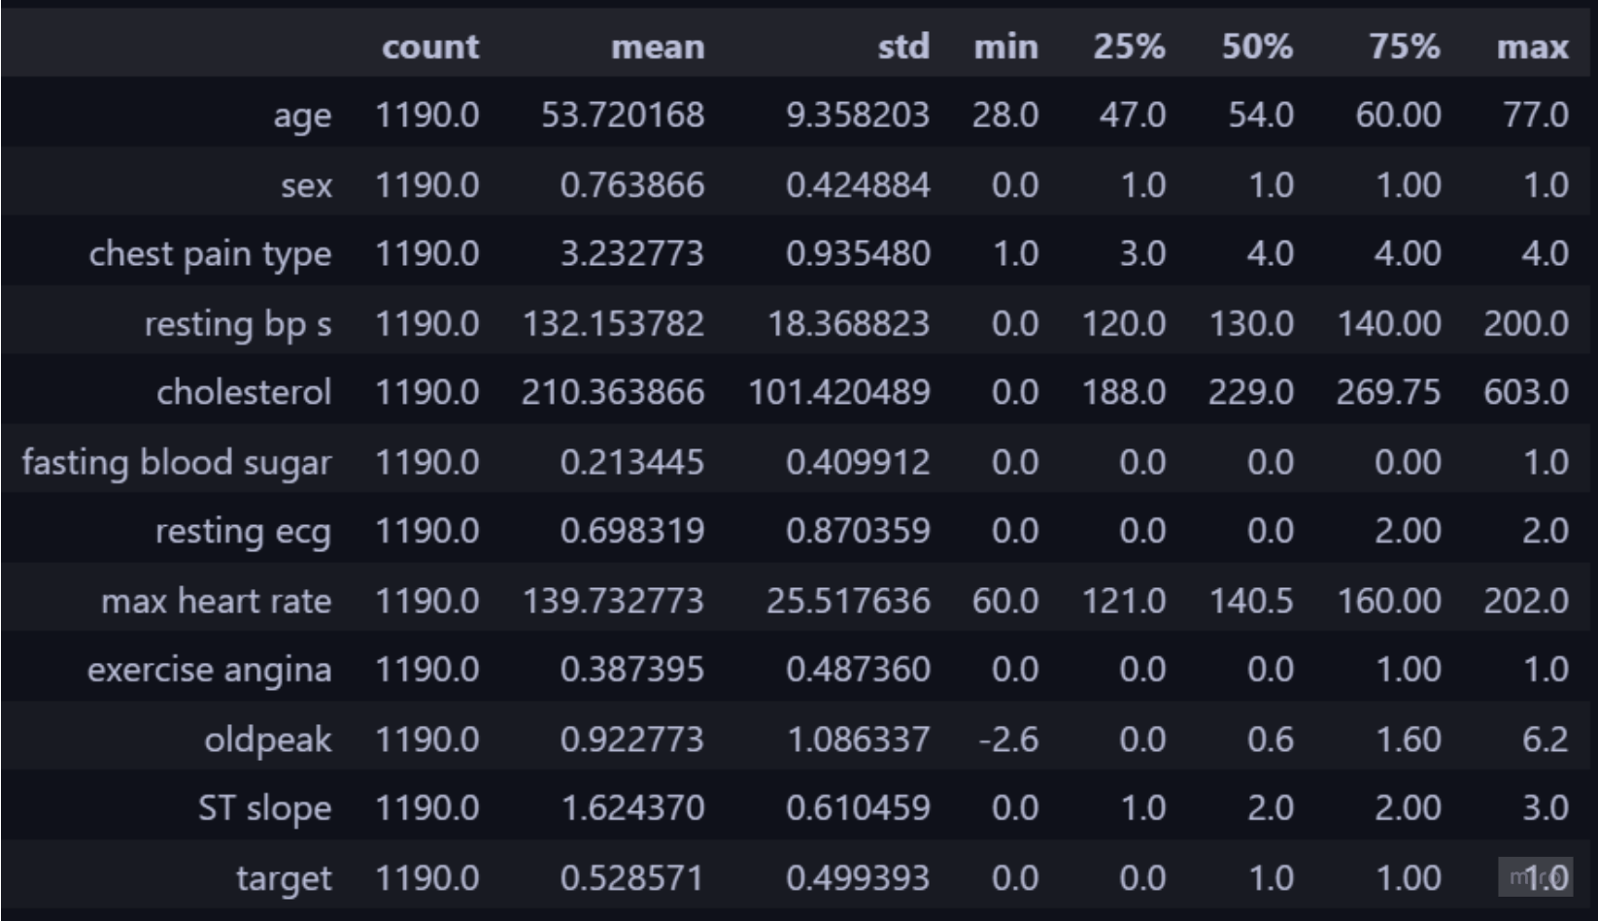

2.1 Old Table

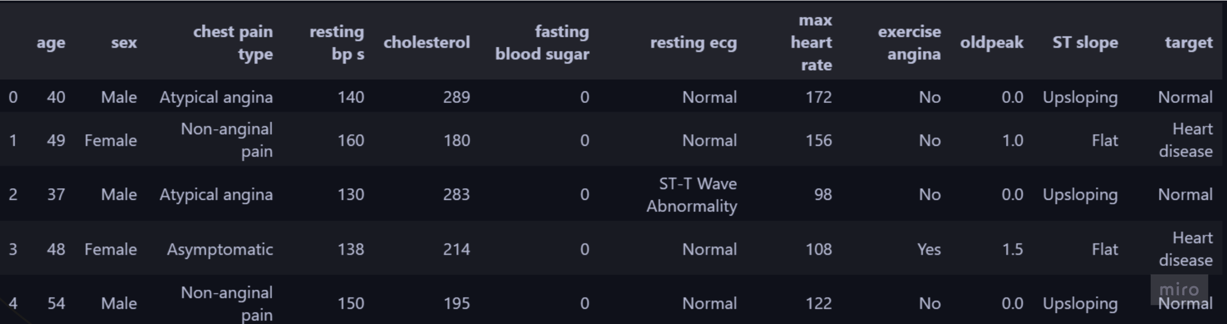

2.1 New Table

2.2. Data Visiualization

At this stage of the project, visualizations for each attribute were created. Missing or incorrect values were identified and replaced with correct values. After this validation process, various graphs were generated using the accurate data. Detailed analyses were then conducted based on these graphs, examining important patterns and relationships in the dataset. These steps were undertaken to enhance the reliability of the data and ensure the accuracy of the analyses.

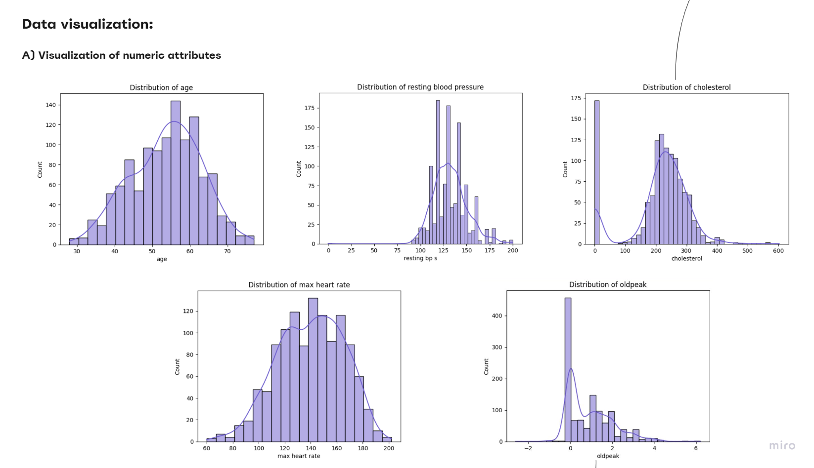

Figure2.2. Visualization

As shown in Figure 2.2.1, cholesterol cannot have a value of 0. Therefore, instances with a cholesterol value of 0 were replaced with the mean of the non-zero cholesterol values. Similarly, the Oldpeak value cannot be less than 0. Consequently, Oldpeak instances with values less than 0 were also replaced with the mean value.

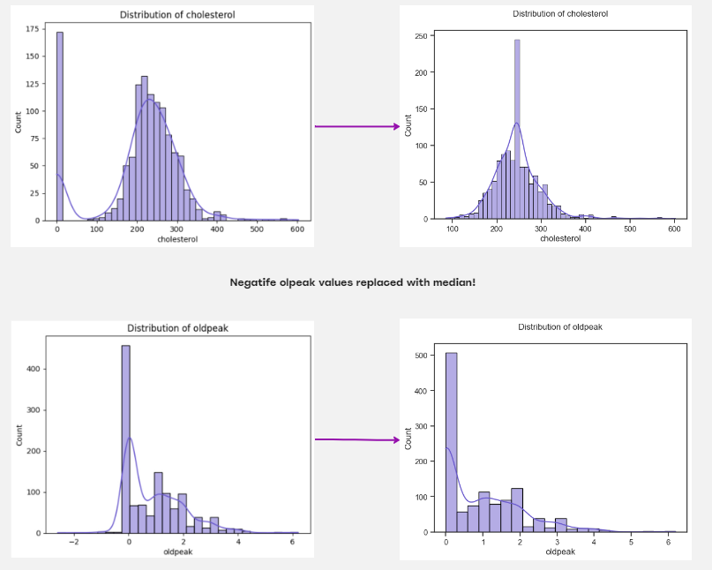

Figure2.2.

As shown Figure 2.2.2, values replaced with median.

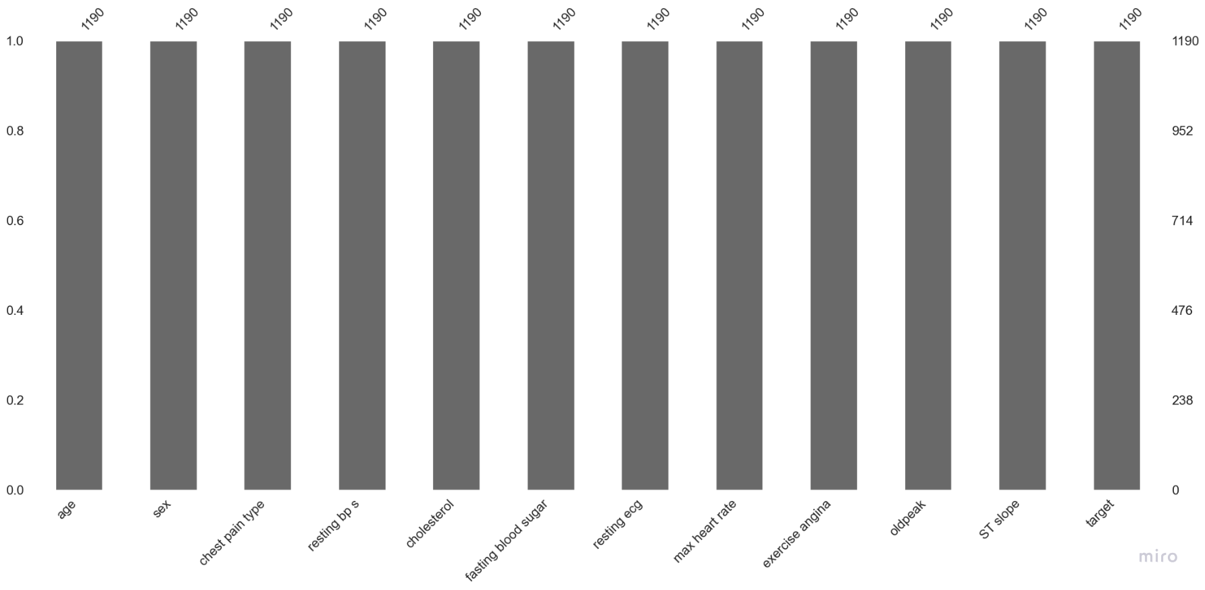

Figure2.2.

As seen in Figure 2.2.3, there are no missing values in our dataset. Incorrect values have also been replaced with the mean.

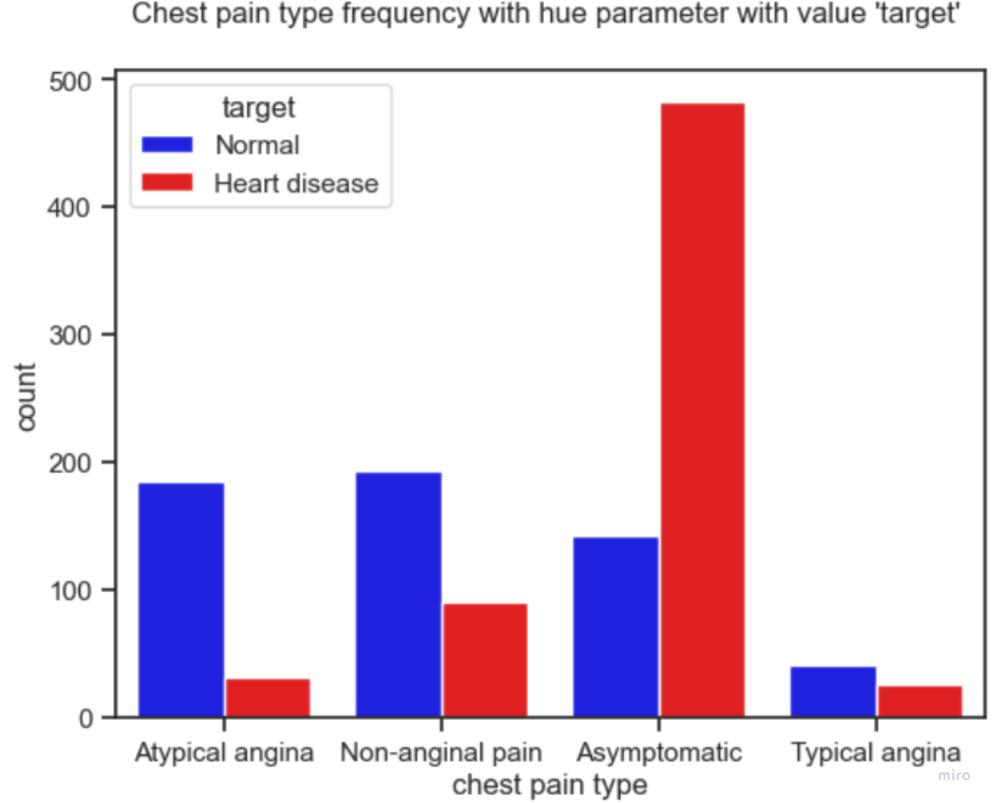

Figure2.2. Chest Pain Type

As shown in Figure2.2.1. **,**it has been observed that many individuals with asymptomatic chest pain have heart disease. This allows us to more clearly see the impact of chest pain type on heart disease. Therefore, we can state that the type of chest pain is an important parameter in determining the role of chest pain in the development of heart disease.

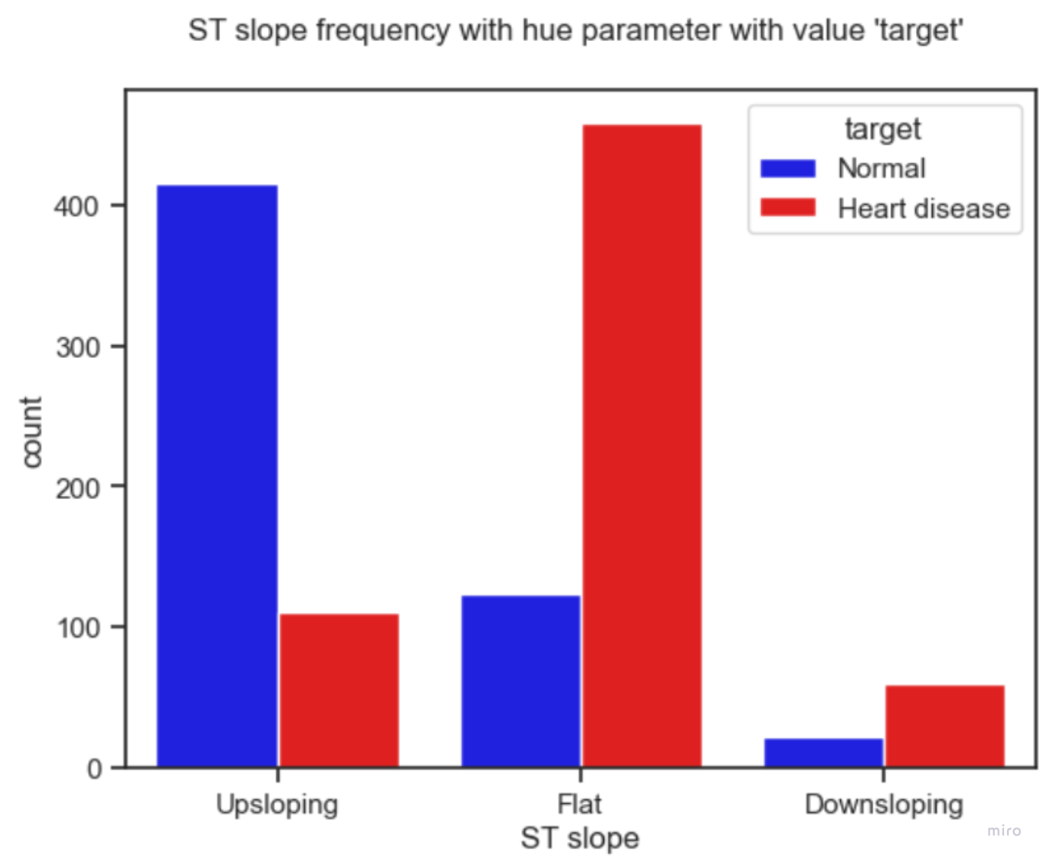

Figure2.2. ST Slope Frequency

As shown in Figure 2.2.3, It is observed that when the slope of the peak exercise ST segment value is flat, the probability of having heart disease is very high, and when it is Upsloping, the probability of having the disease is low.

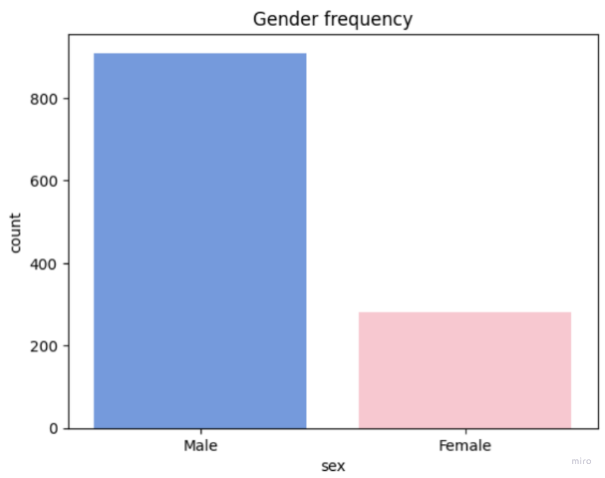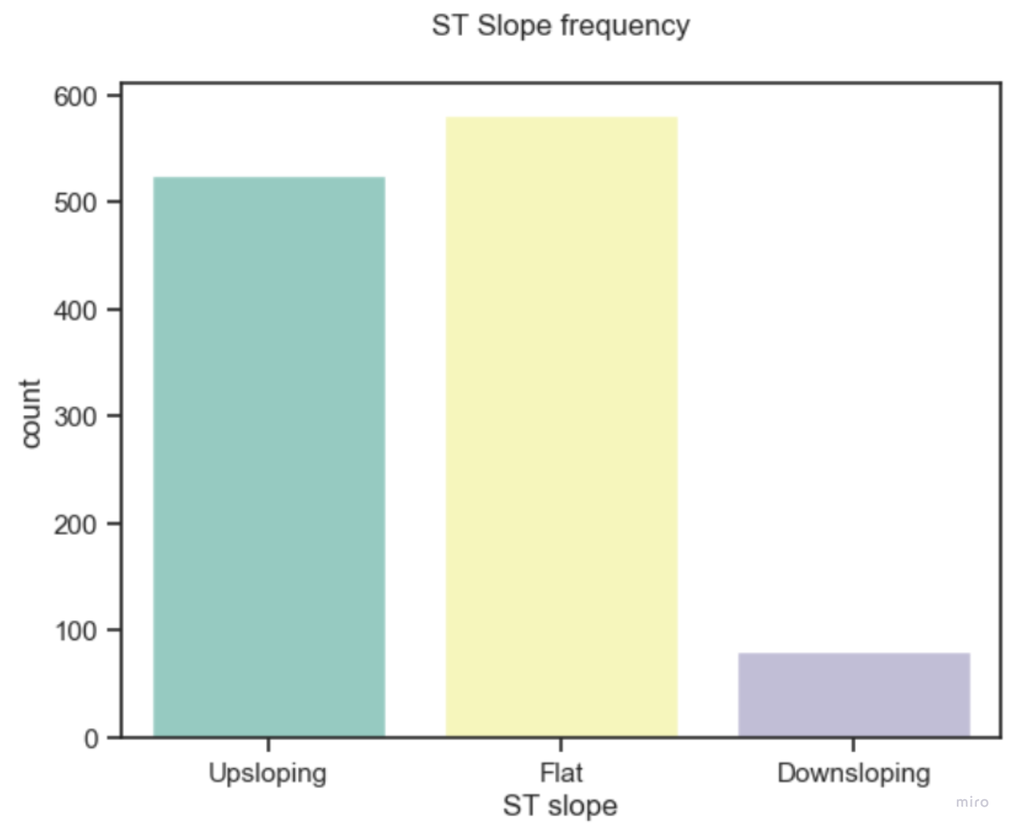

Figure2.2. 6 Gender Frequency

Figure2.2. St Slope Frequency

As shown Figure 2.2.4 and Figure 2.2.5, **Gender and ST slope attributes have some imbalance!.We will consider this imbalance when separating the data when we switch to machine learning algorithms.**

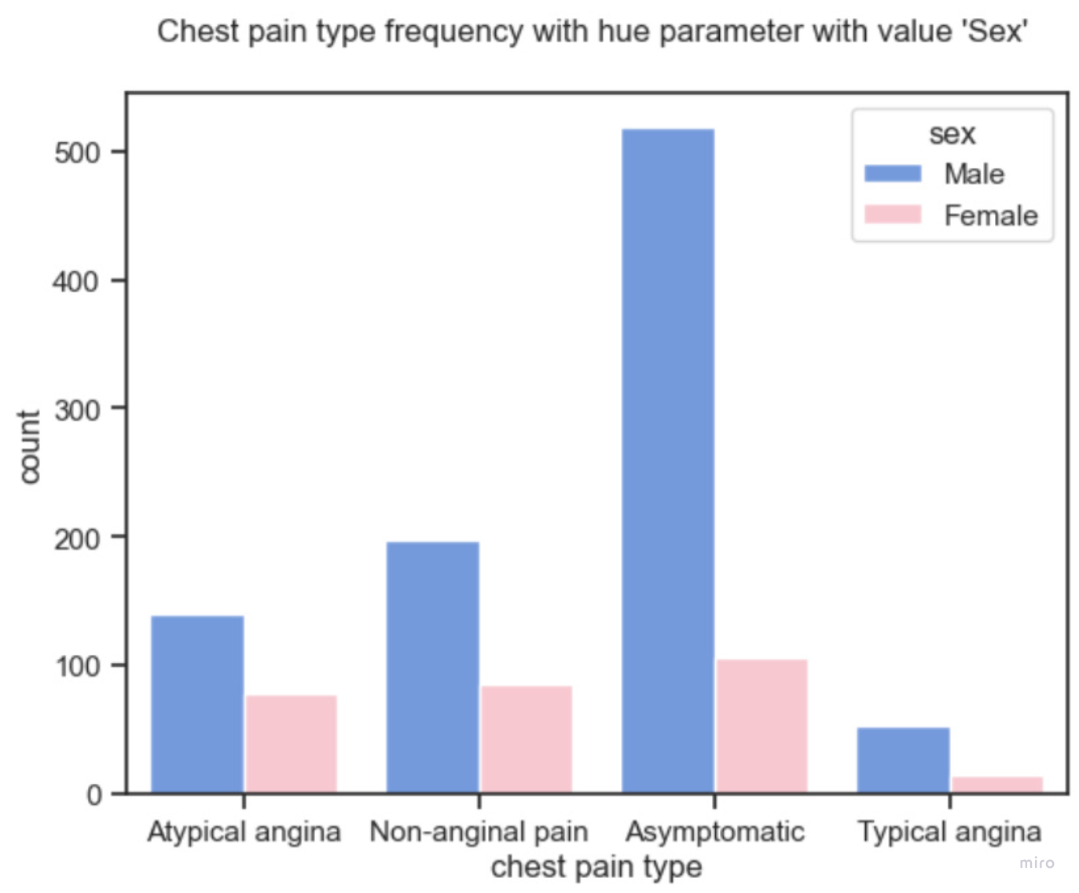

Figure2.2. Chest Pain Type

**Here we see that men have much more chest pain type asymptomatic complaints than women.**

****3- Machine Learning****

**Within the scope of our project, we will divide the machine learning section into two main parts. In the first part, we will apply various machine learning algorithms to our raw data without using the one hot encoding technique and analyze their performance. At this stage, we will observe how the algorithms perform without any encoding applied to the data.**

**In the second part, we will apply one hot encoding to our dataset. One hot encoding transforms categorical data into binary vectors, allowing machine learning algorithms to work more efficiently with these types of data. After completing this transformation, we will reapply the same machine learning algorithms to our dataset and compare the results with those obtained in the first part. This will enable us to assess the impact of one hot encoding on the performance of the algorithms.**

**The machine learning algorithms to be applied in both parts are as follows:**

* **Decision Tree Classifier: An algorithm that classifies data using decision trees.**
* **Random Forest: A method that creates multiple decision trees and combines their results for classification.**
* **Support Vector Machines (SVM): An algorithm that seeks to find the optimal hyperplane to separate data into different classes.**
* **Logistic Regression: A method used in binary classification problems that separates data based on a linear boundary.**
* **Naïve Bayes: An algorithm that classifies data based on Bayes' theorem and uses simple probability models.**
* **Adaptive Boosting (AdaBoost): An ensemble method that combines multiple weak classifiers to form a strong classifier.**
* **K-Nearest Neighbors (KNN) Algorithm: An algorithm that classifies a new data point based on the class of its nearest neighbors.**

**By adopting this systematic approach, we will be able to comprehensively evaluate the effectiveness of data preprocessing techniques and different machine learning algorithms in diagnosing heart disease.**

****3.1. Section 1 -Machine Learning Algorithm****

****1-Decision Tree Classifier****

**During the decision tree training process, we trained our models with optimal parameters using three different criteria (Gini, Entropy, Log_loss). At this stage, we separately trained our models for each criterion to determine the parameters that showed the best performance. As a result, we identified the optimal parameters for each criterion and compared their performances to determine which criterion provided the best results. Through this comprehensive analysis, we clearly identified the criterion and parameter combination that maximized the performance of our decision tree models.**

**Grid of parameter values for Decision Tree:**

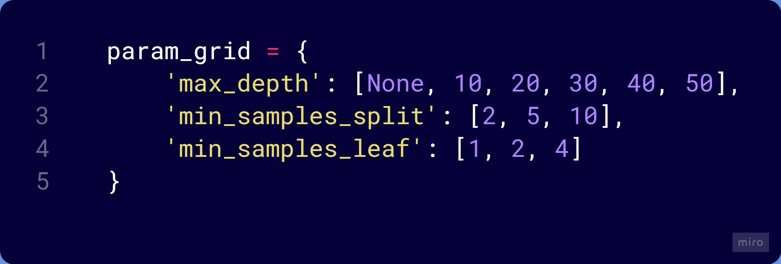

Best parameters for each criterion:

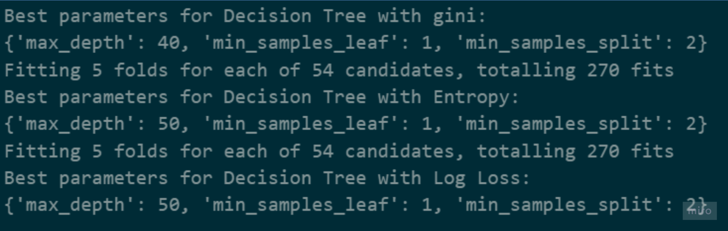

And the classification reports for each criterion entropy, gini, log_loss:

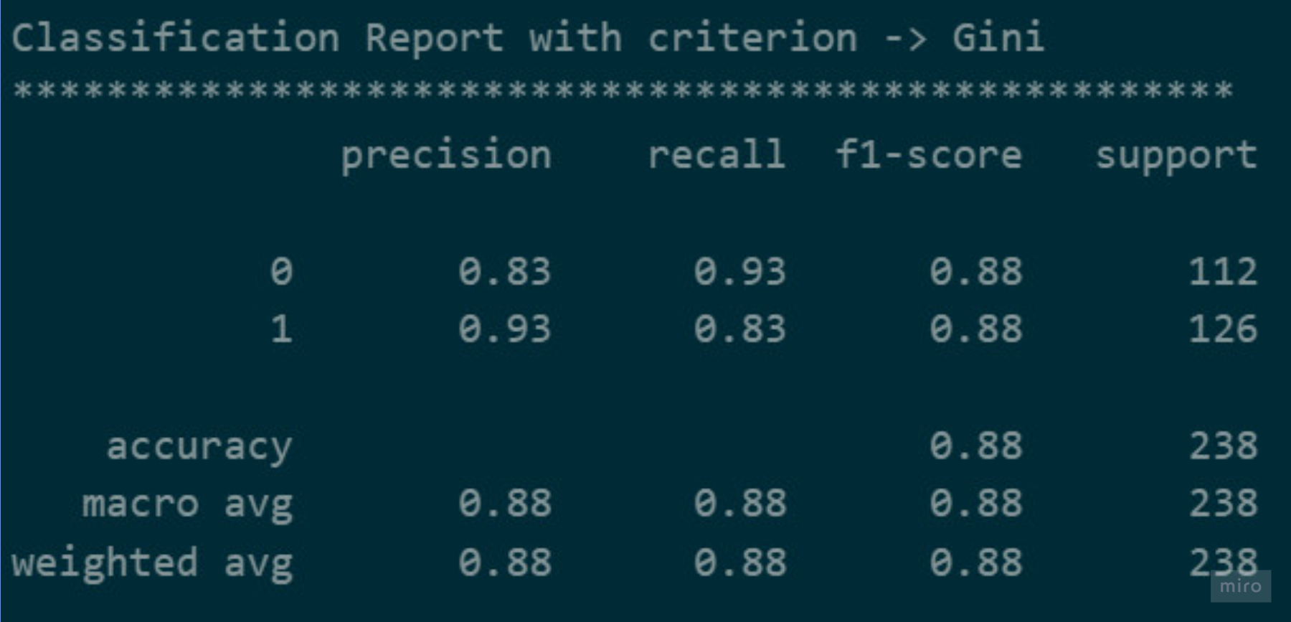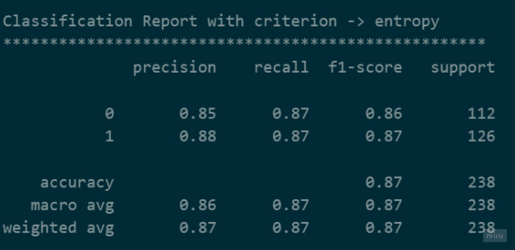  
 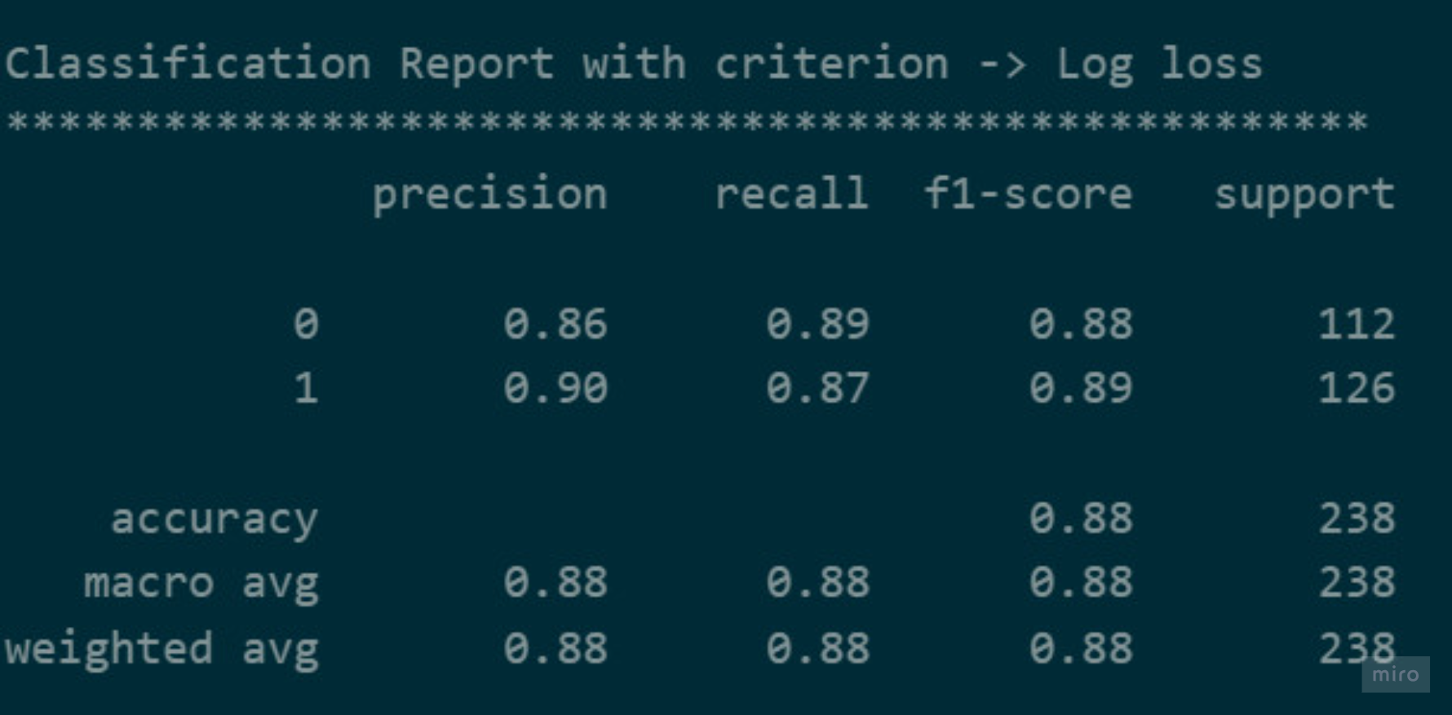

Figure3.1. 1 Entropy Figure 3.1.2. Gini

Figure3.1. 3 Log_loss

When evaluated using the Gini and log_loss criteria, the algorithm demonstrated slightly better performance compared to the entropy criterion. This indicates that, for our specific dataset and problem, the Gini and log_loss criteria were more effective in enhancing the decision tree's predictive accuracy and overall performance.

2-Random Forest

Grid of parameter values for random forest:

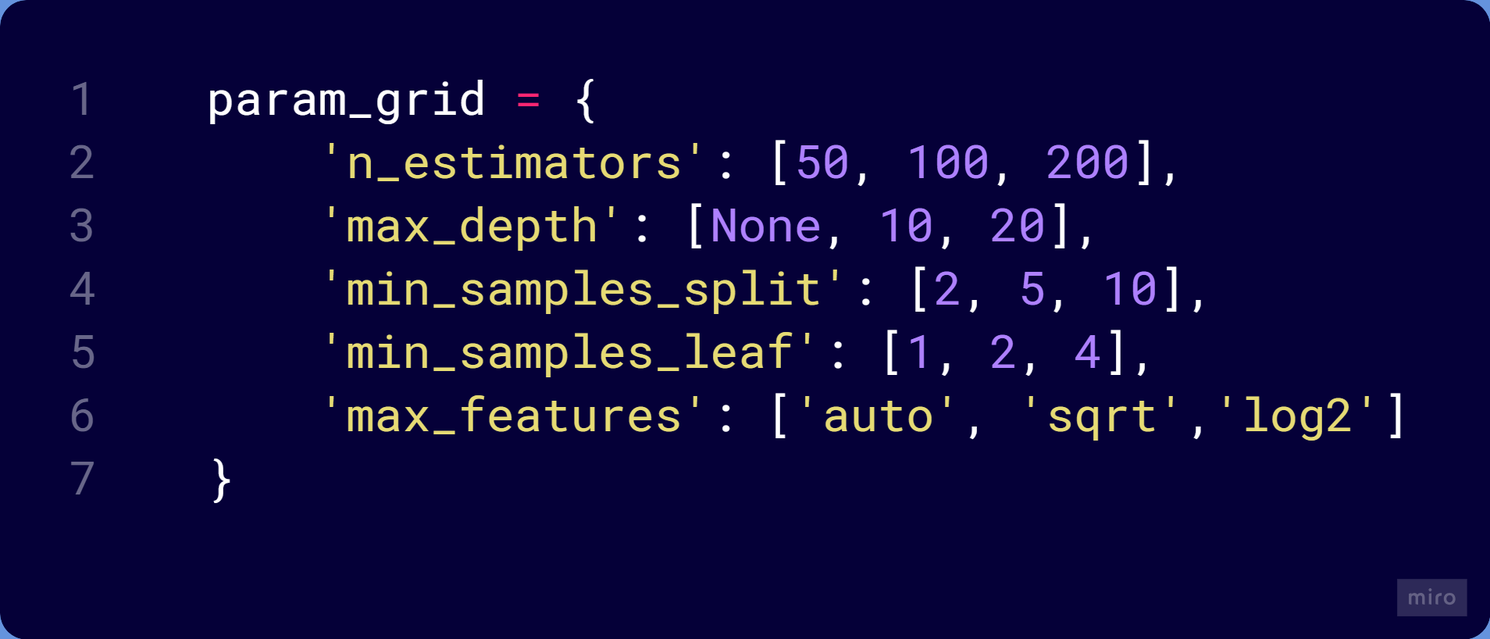

Best parameter:





And the classification report:

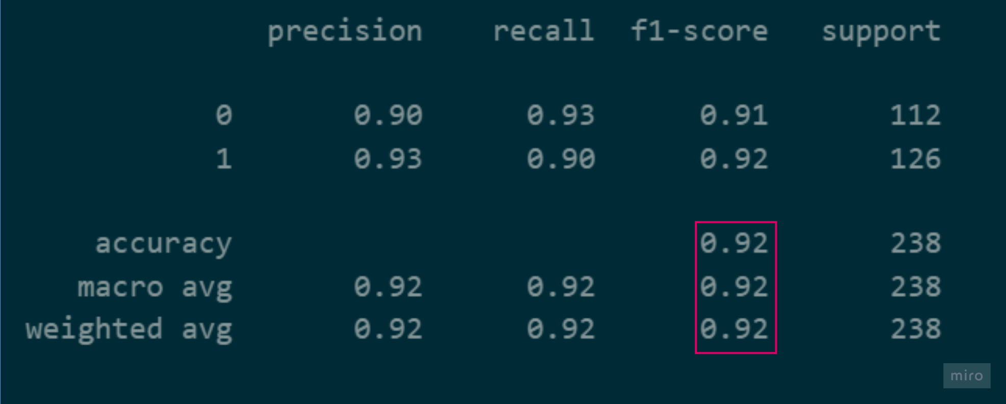

For the decision trees and random forest algorithms, we opted not to standardize the data during preprocessing. This decision was based on the understanding that standardization is generally unnecessary for these algorithms. Since decision trees and random forest models partition the feature space based on threshold values, the scale of the input features does not impact their performance. Therefore, we chose to maintain the original scale of the data to avoid potentially unnecessary transformations that could obscure the interpretability of the models and introduce additional computational overhead.

3-Support Vector Machines

For the support vector machines algorithm, the process of optimizing our dataset for C, gamma, and kernel parameters took a considerable amount of time and did not yield the desired results. Consequently, we decided to train only one model for each kernel and thoroughly examine their performances. Additionally, we trained the models using both standardized and non-standardized datasets. This allowed us to observe the impact of the standardized version of the data on performance. The outcomes of these analyses helped us gain a better understanding of how the support vector machines algorithm behaves under different kernel choices and data standardization options.

Classification report for non-standartized data:

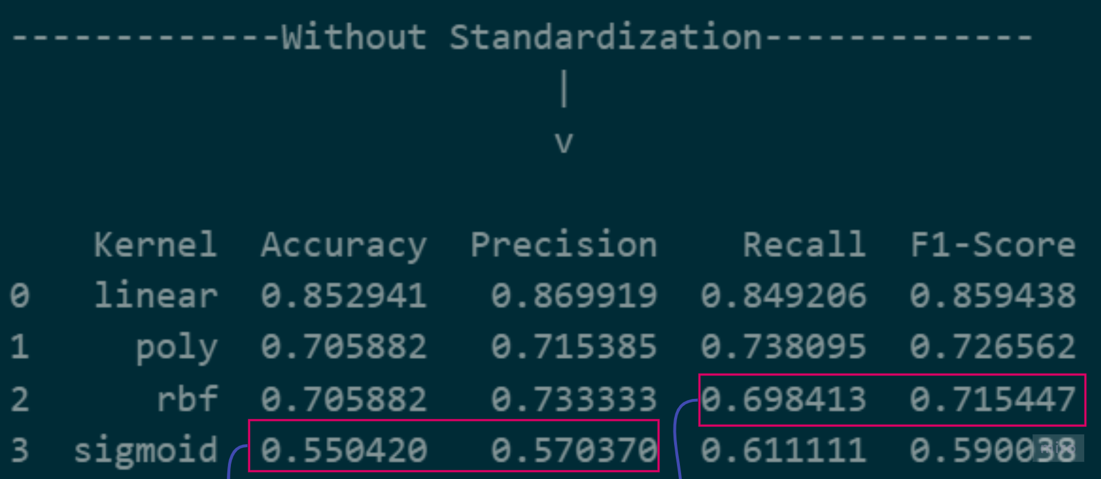

Figure3.1.1.

Except for the linear kernel, it can be said that the success of the remaining kernels is low without standardization

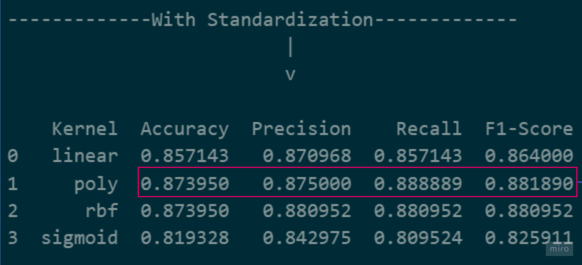

Figure3.1. 2

Following the standardization of data, a notable enhancement in the performance of all kernels becomes evident! This observation leads us to conclude that among the standardized data, the polynomial kernel emerges as the most successful. Moreover, we conducted a thorough examination of the impact of C and gamma parameters on model accuracy through parameter adjustments. However, our observations revealed that these parameter variations did not yield a significant effect on performance. Despite our meticulous exploration, the relative stability of performance across parameter adjustments underscores the robustness of the support vector machines algorithm in handling diverse datasets and parameter configurations.

4-Logistic Regression

Logistic regression is a classification algorithm used in binary or multiclass classification problems. Its primary objective is to predict the probability of the dependent variable (class label) based on one or more independent variables (predictor variables). Typically, the output of logistic regression is expressed as a probability value between 0 and 1, which is then thresholded to assign classes.

Grid of parameter values for logistic regression:

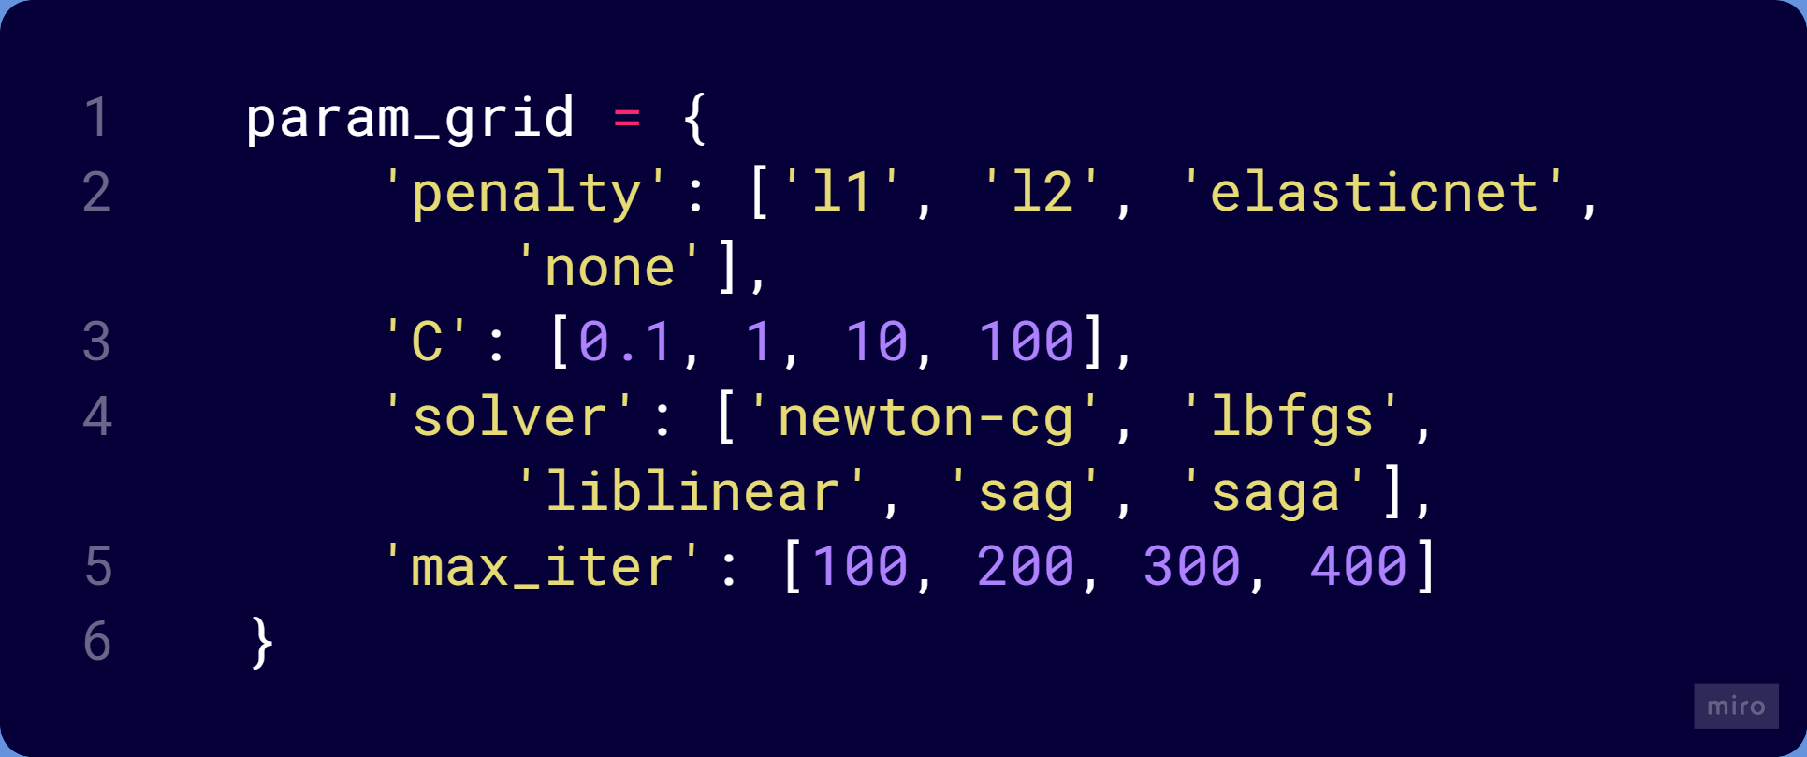

Best parameters:



Classification report:

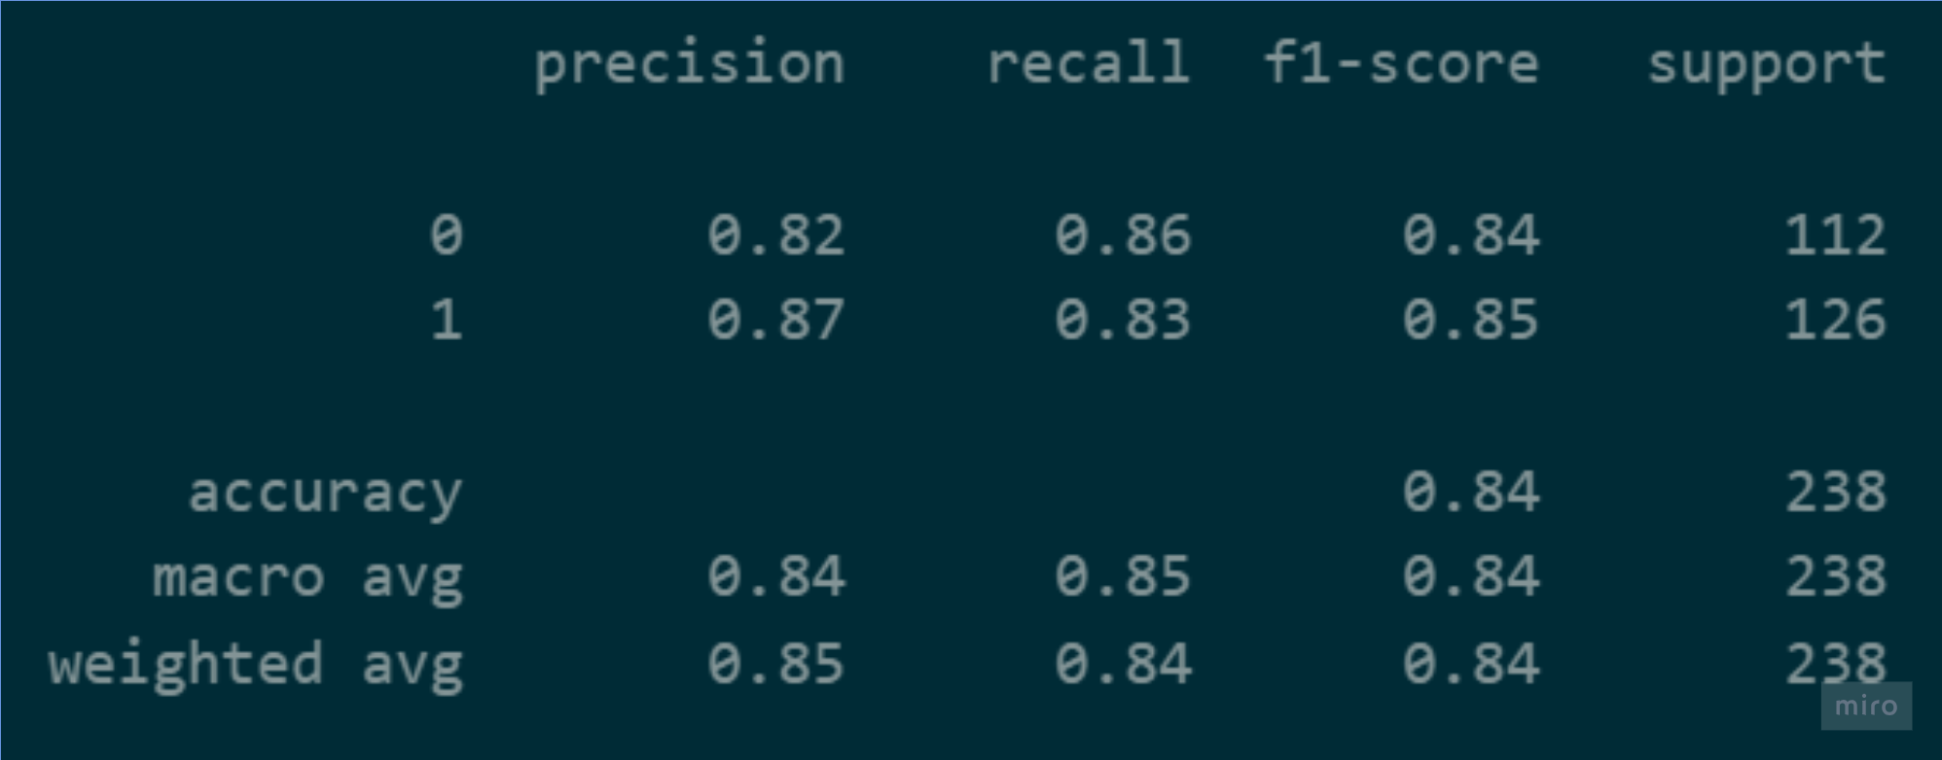

****5-Naïve Bayes****

Since the Naïve Bayes algorithm inherently lacks parameter options, we were relieved from the necessity of engaging in hyperparameter optimization endeavors. This absence of parameter tuning spared us from the complexities associated with fine-tuning model settings, allowing us to focus our efforts on other aspects of the model development process.

Classification Report:

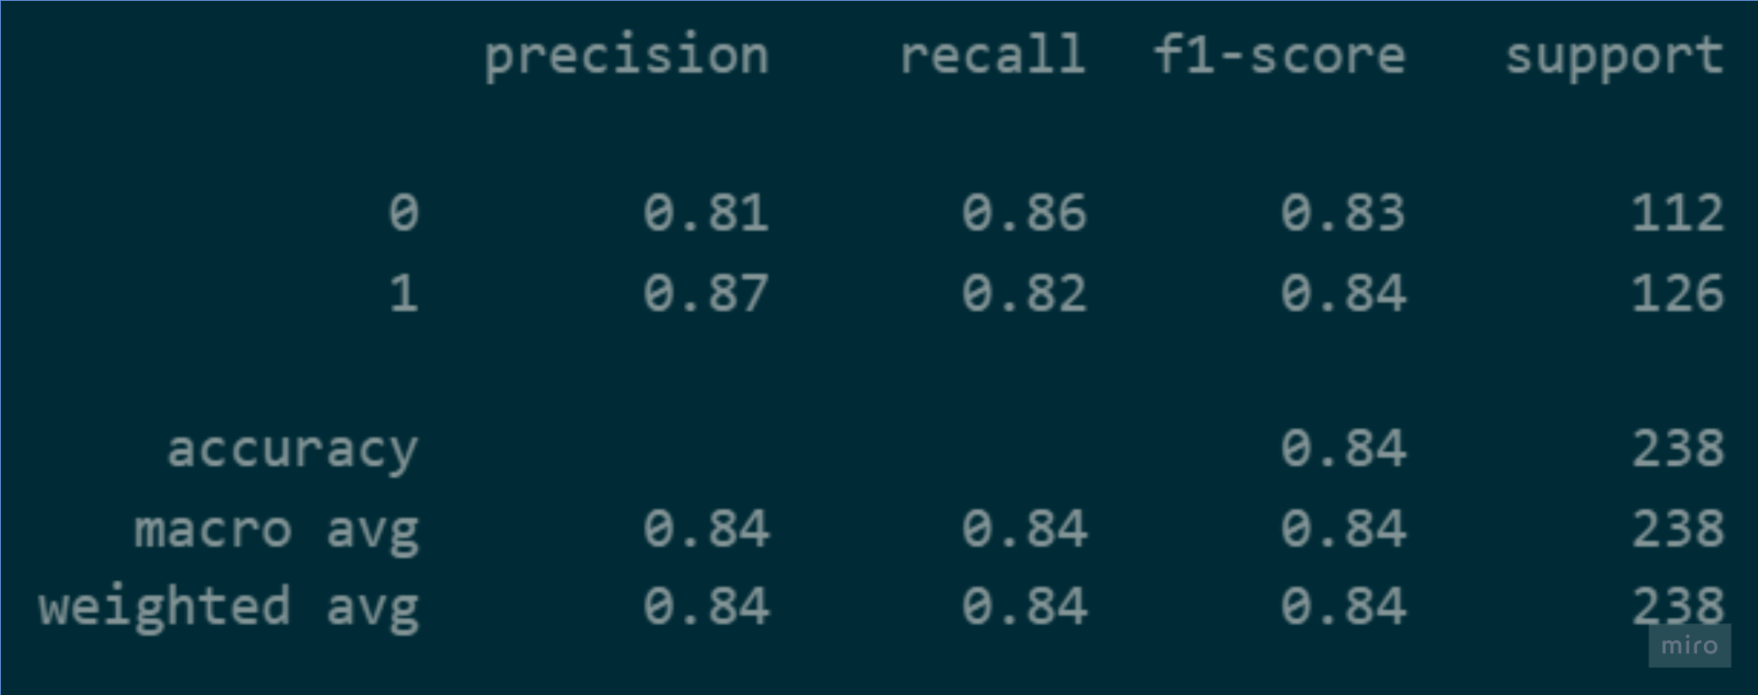

6-Adaptive Boosting

AdaBoost is an ensemble method that works by combining multiple weak learners to create a strong learner. In our case, Decision Tree Classifier is used as the base estimator.

Grid of parameter values for adaptive Boosting:

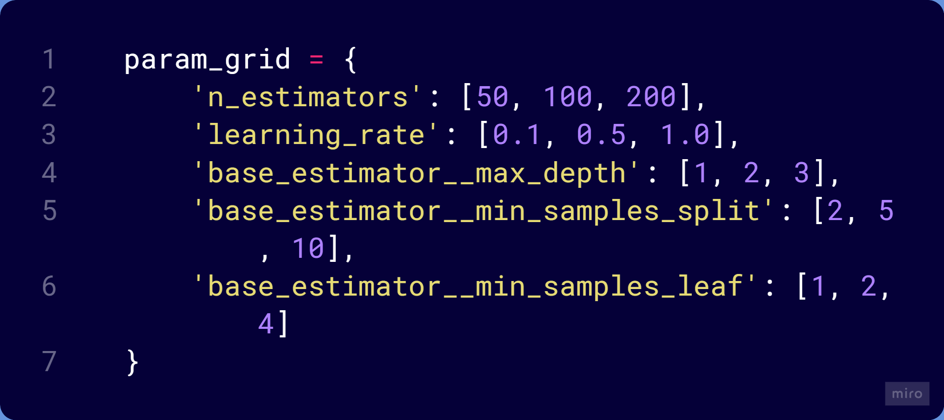

Best parameters:





Classification Report:

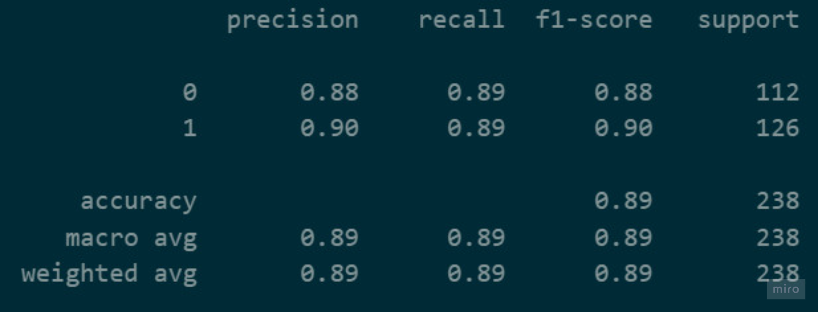

7-KNN Algorithm

Grid of parameter values for KNN algorithm:

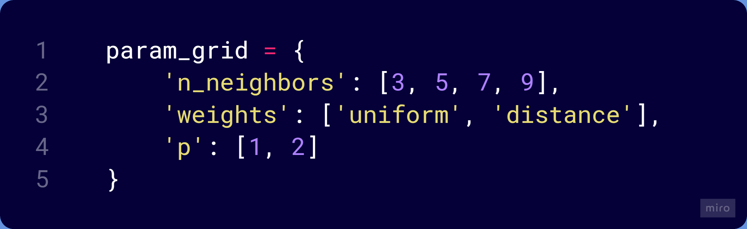

Best parameters:

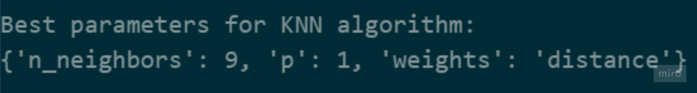

Classification report for KNN Algortihm:

Subsequently, we sought to investigate the potential impact of varying the number of neighbors on the accuracy of the model. As part of this analysis, we generated the following graphical representation to visualize the relationship between the number of neighbors and the corresponding accuracy scores. By systematically examining this relationship across different configurations, we aimed to elucidate any discernible patterns or trends that could inform the selection of an optimal number of neighbors for our KNN algorithm.

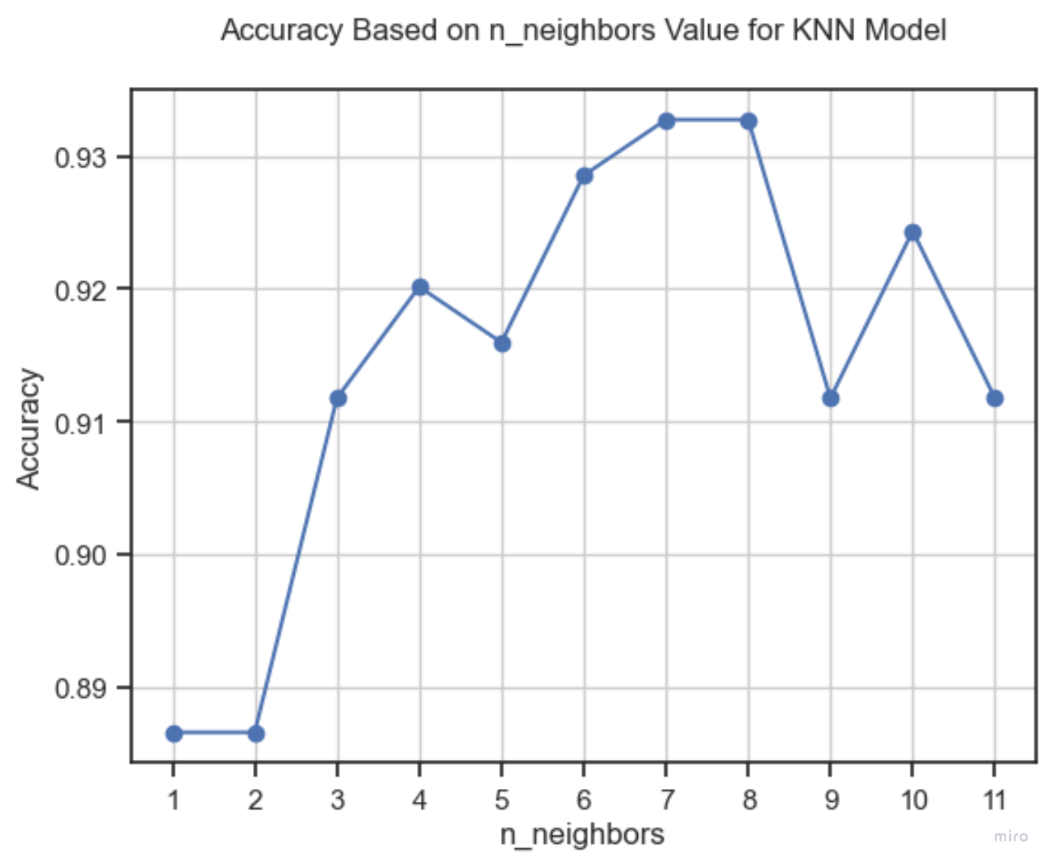

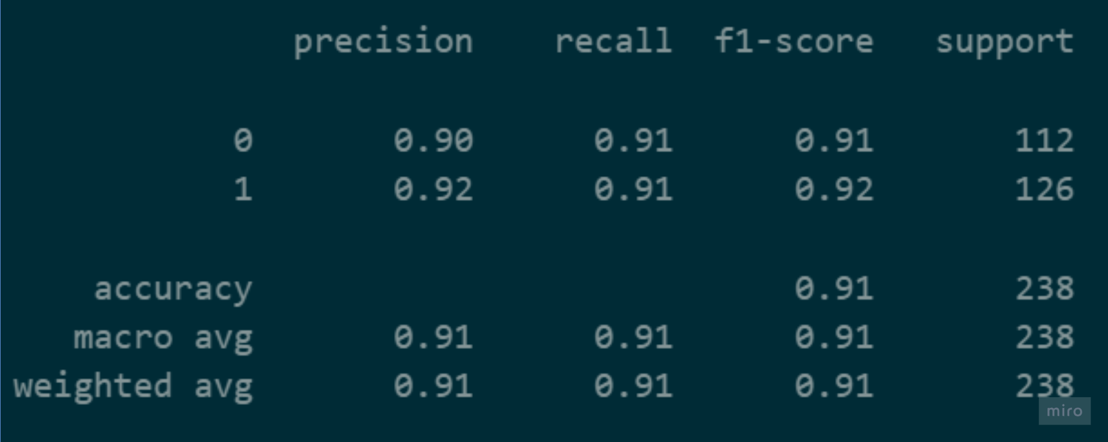

Comparison of Results After Section1:

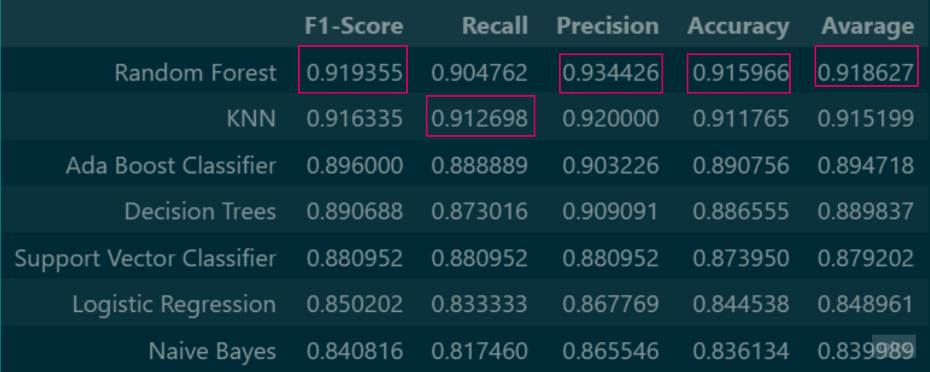

3.2.Section2- Machine Learning Algorithm

The second phase of our machine learning process is being initiated. In the previous stage, the one hot encoding technique was integrated into our algorithms without being applied to our dataset, and their performance was evaluated. Now, in this phase, the categorical features in our dataset will be transformed using the one hot encoding method. As a result of this process, separate columns will be created for each class of the categorical features. With this transformation, our dataset will be updated, and the performance of our machine learning models will be reanalyzed. This will allow a better understanding of the impact of the one hot encoding technique on our algorithms.

1-Decision Tree Classifier

While training the decision trees, we first trained our models with optimal parameters using 3 different criteria (Gini, Entropy, Log_loss). As a result, we determined the optimal parameters for each criterion and saw the criterion that gave the best results.

Grid of parameter values for decision tree:

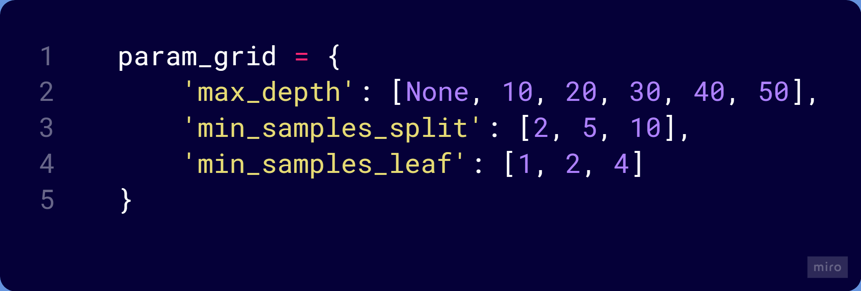

Best parameters for each criterion:

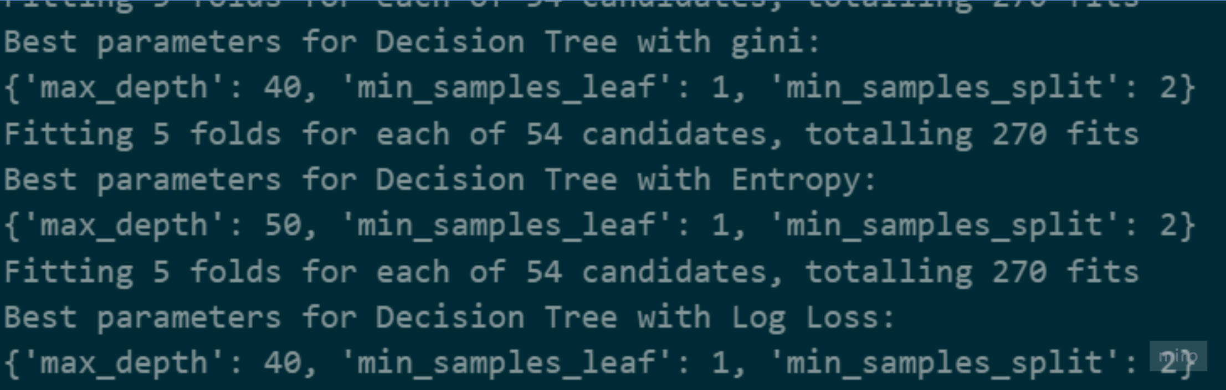

Classification Reports for Each Criterion:

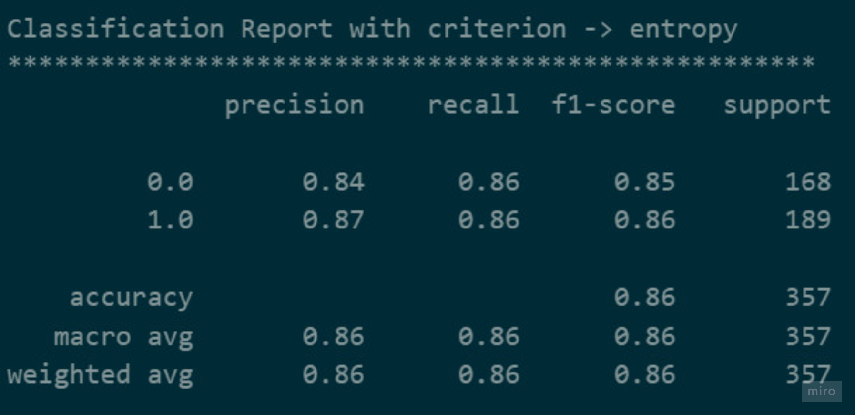

Figure3.2. Entropy

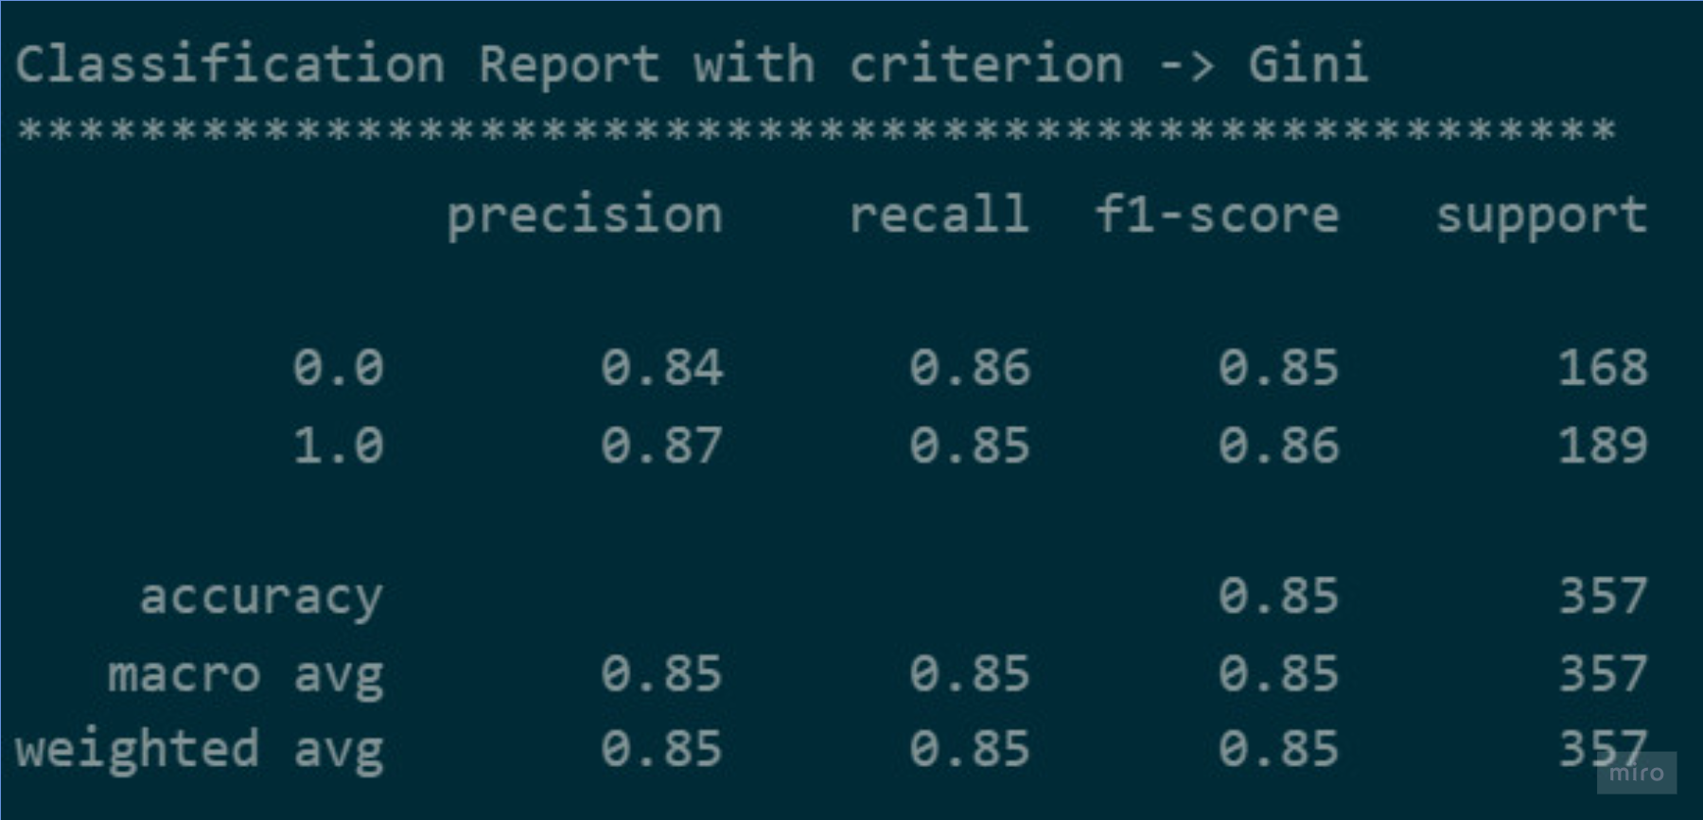

Figure3.2. Gini

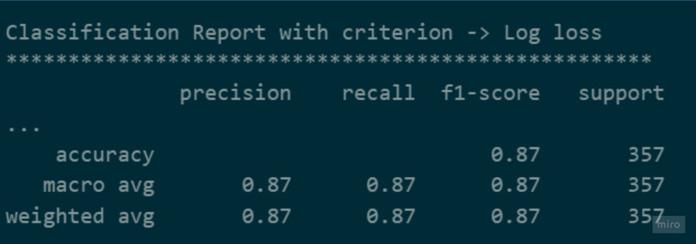

Figure3.2. Log_Loss

2- Random Forest

Grid of parameter values for random forest:

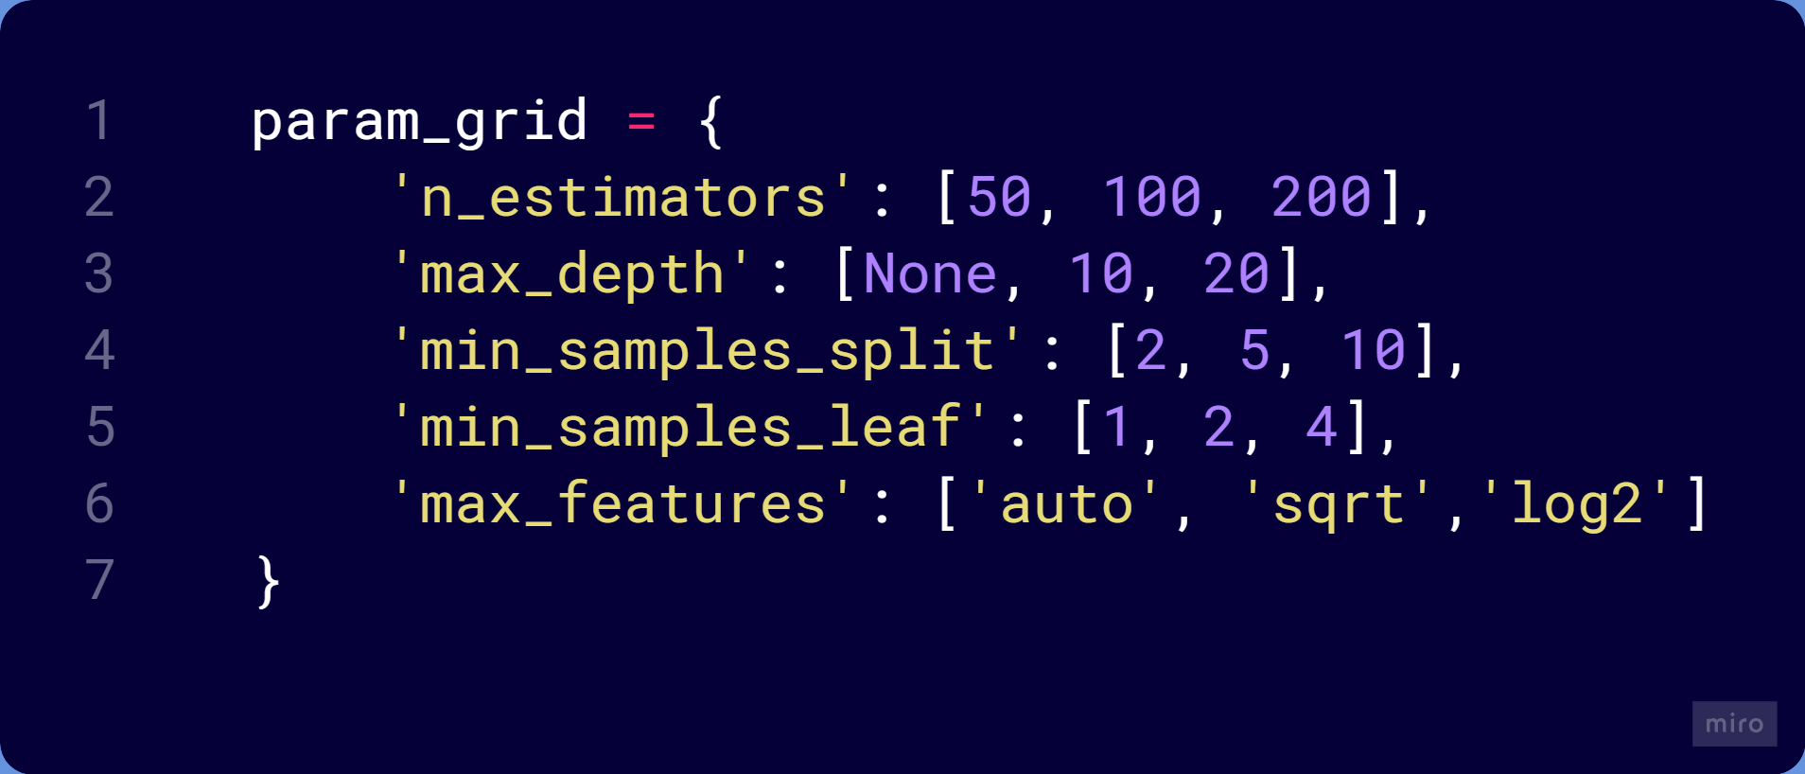

Best Parameters for random forest:





Classification Report for random forest:

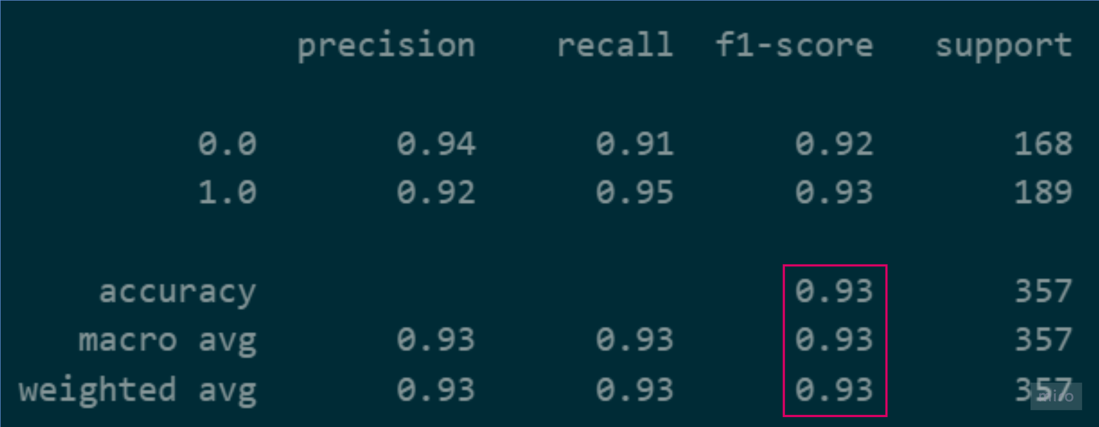

3-Support Vector Machine

For the support vector machines algorithm, optimizing our data set for C, gamma and kernel parameters took quite a long time and did not work out. That's why we only trained one model for each kernel and examined their impact on performance. And in addition, we trained the model using both standardized and non-standardized data to observe the effect of the standardized version of the data on performance.

Classification reports for non-standartized data:

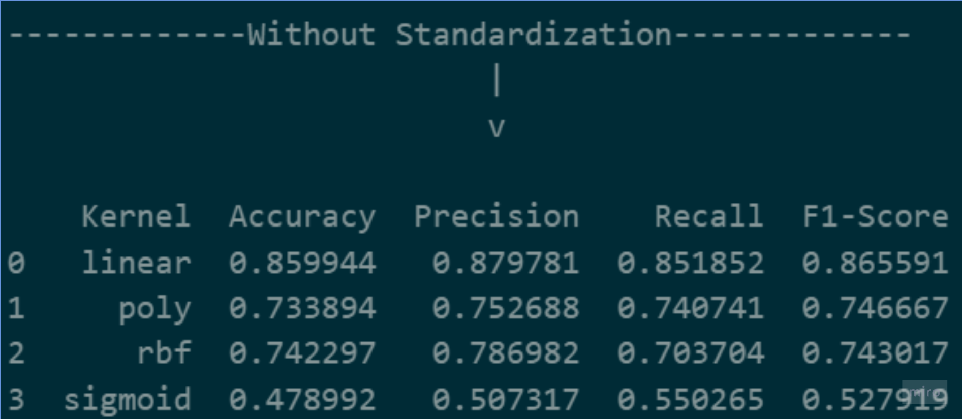

Classification for standarttized data:

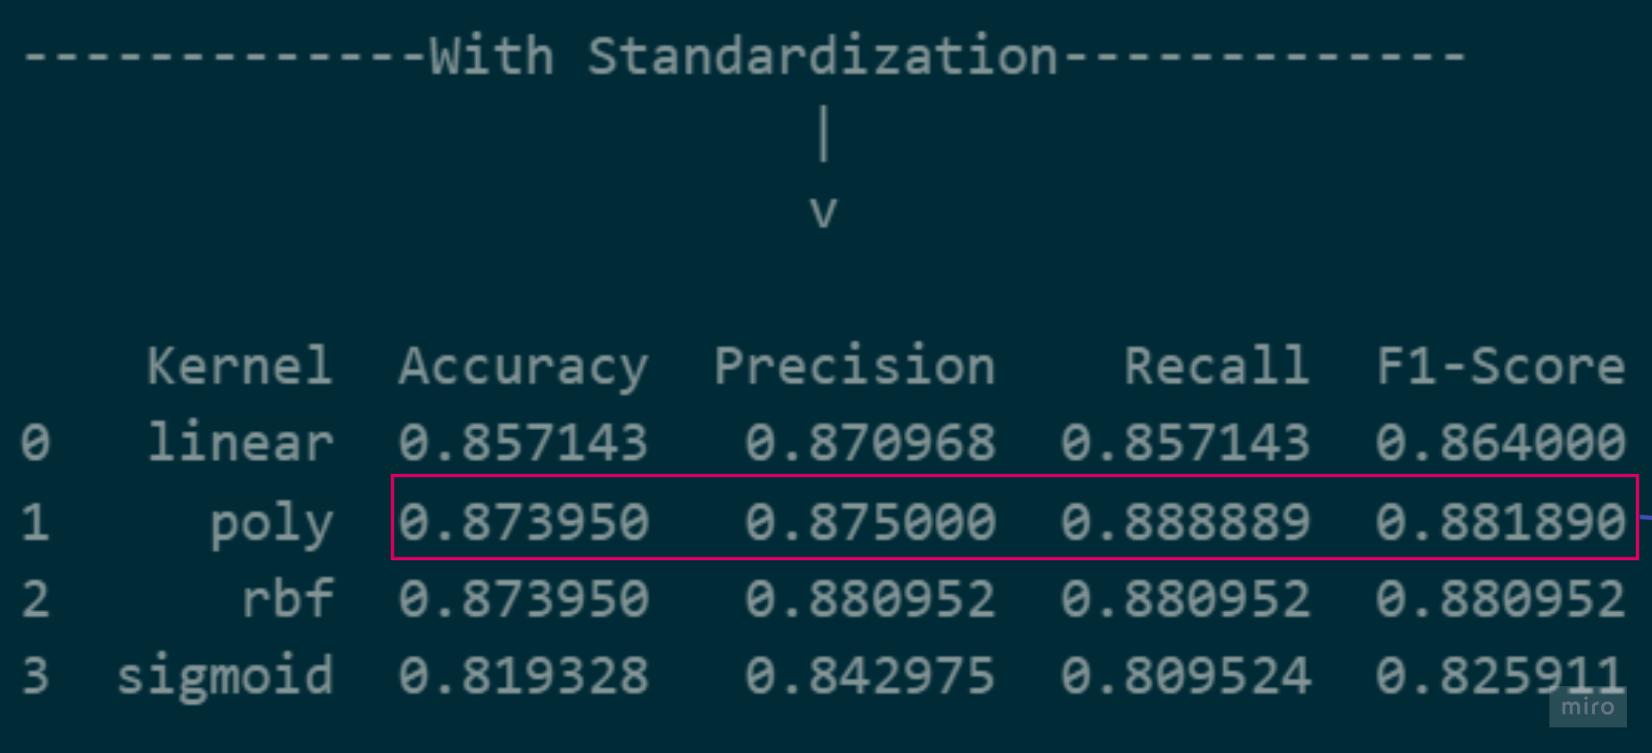

After the data was standardized, a clear increase in the success of all kernels was observed. From this, it was concluded that the most successful kernel on standardized data is the polynomial kernel. Additionally, a series of experiments were conducted to examine the effects of the C and gamma parameters on the model's accuracy by altering these parameters. However, it was observed that changes in these parameters did not have a noticeable impact on performance.

4-Logistic Regression

Grif of parameter values forlogistic regression:



Best parametera for logistic regression:

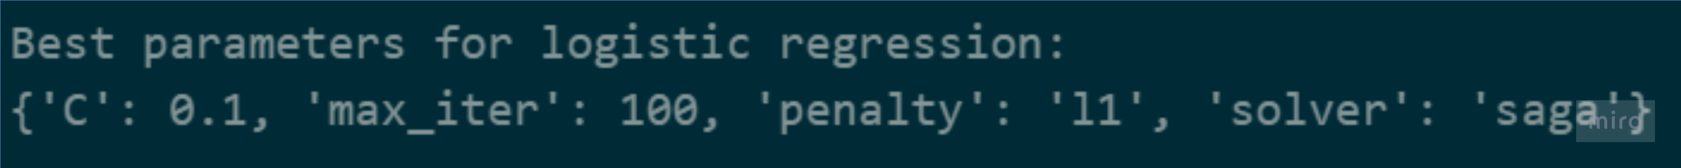

Classification reports for logistic regression:

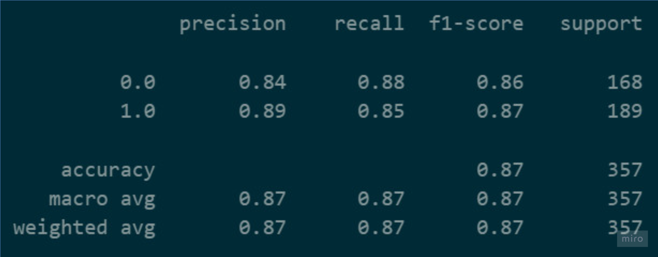

****5-Naïve Bayes****

Since there are no parameter options for the Naïve Bayes algorithm, we did not need to do any hyperparameter optimization here.

Classification reports for **Naïve Bayes:**

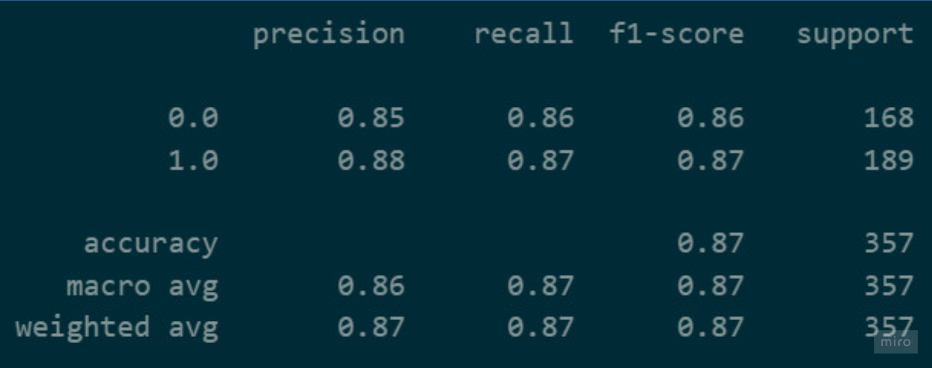

6-Adaptive Boosting

AdaBoost is an ensemble method that works by combining multiple weak learners to create a strong learner. In our case, Decision Tree Classifier is used as the base estimator.

Grid of parameters for adaptive boosting:

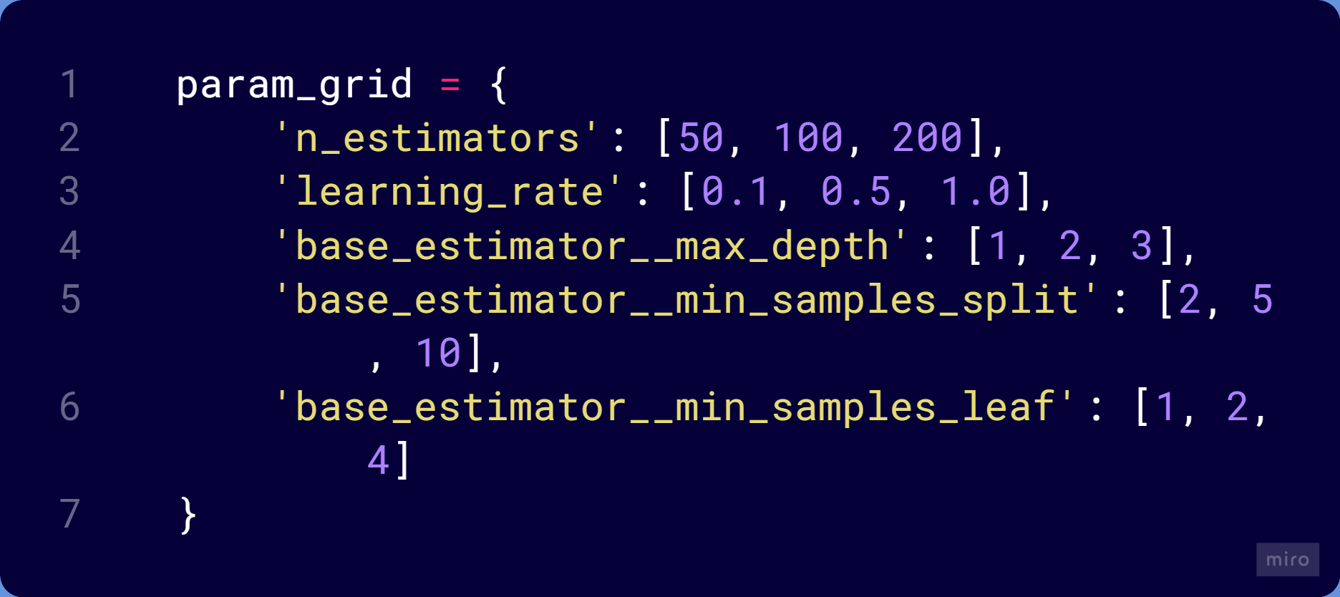

Best parameters for each adaboost:





Classification repaort for adaboost:

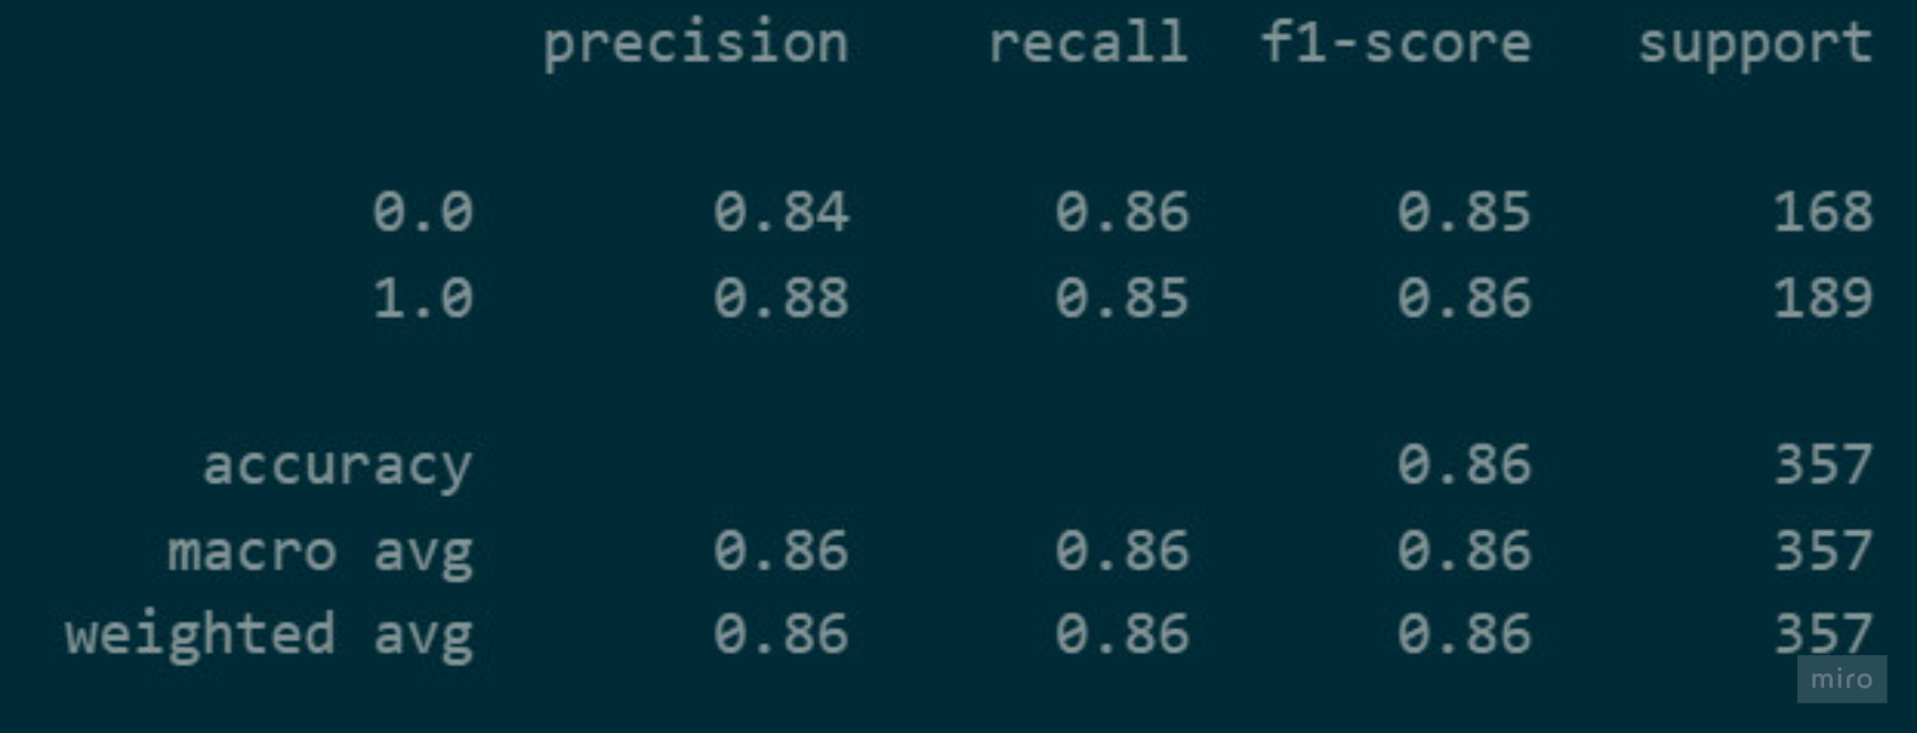

7-KNN Algorithm

Grid parameter values for KNN Algorithm:

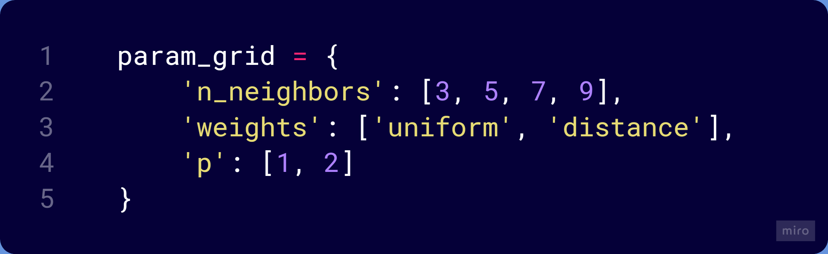

Best parameters for KNN algorithm:



Classification report for KNN algorithm:

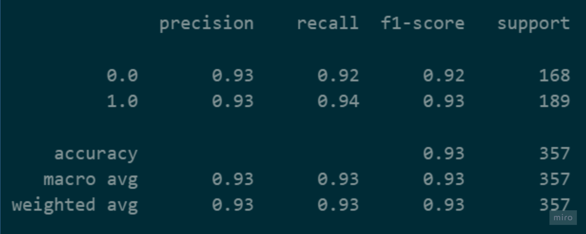

Comparison Results After Section2

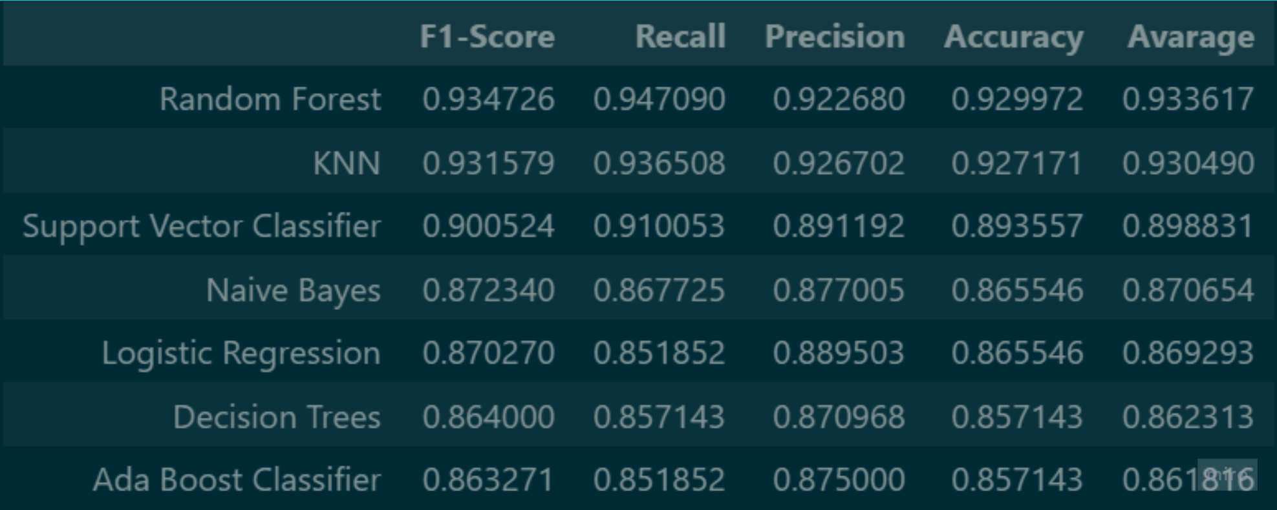

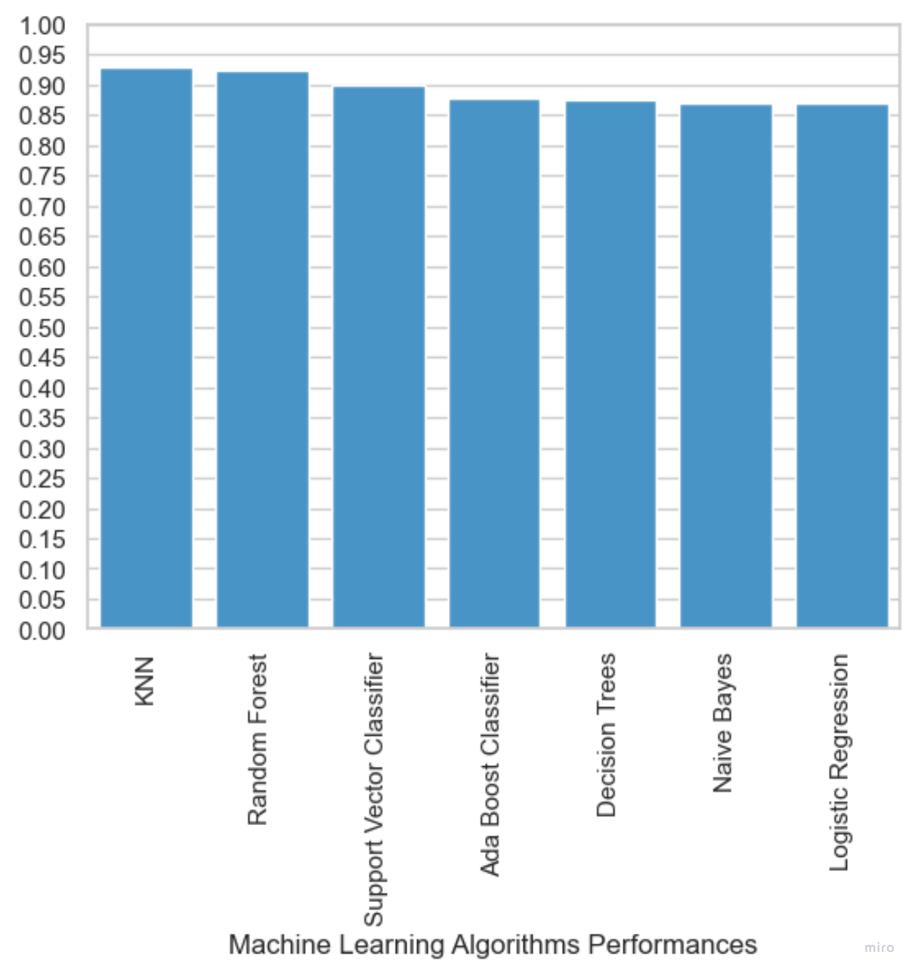

The success of Random Forest, KNN, Support Vector Classifier, Naive Bayes, Logistic Regression Algorithms has increased compared to the previous stage. However, the success of decision tree and Ada Boost algorithms has decreased.